**Practical: 01**

**Aim:** Overview of SQL Server 2008/2012 Databases and Analysis Services. Create a Sample Database Star Schema using SQL Server Management Studio. Design, Create and Process cube by identifying measures and dimensions for Star Schema, for an assigned system by replacing a dimension in the grid, filtering and drilldown using cube browser.

**Software/ Hardware:** Microsoft Visual Studio 2010, Microsoft Sql Server Managment Studio

**Theory:**

**OLAP Operations**  
OLAP provides a easy surroundings for interactive information analysis. variety of OLAP information cube operations exist to pass off completely different views of knowledge, permitting interactive querying and analysis of the information.  
The most standard user operations on dimensional information are:  
Roll up: The roll-up operation (also known as drill-up or aggregation operation) performs aggregation on an information cube, either by ascension up an inspiration hierarchy for a dimension or by ascension down an inspiration hierarchy, i.e. dimension reduction.   
  
Roll Down: The descend operation (also known as drill down) is that the reverse of roll up. It navigates from less elaborate information to a lot of elaborate information. It are often complete by either stepping down an inspiration hierarchy for a dimension or introducing further dimensions.  
  
Slicing: Slice performs a variety on one dimension of the given cube, so leading to a subcube.   
  
Dicing: The dice operation defines a subcube by acting a variety on 2 or a lot of dimensions.  
  
Pivot: Pivot otheriwise referred to as Rotate changes the dimensional orientation of the cube, i.e. rotates the information axes to look at the information from completely different views. Pivot teams information with completely different dimensions.  
  
**Other OLAP operations**  
Some OLAp operations include:  
  
Scoping: proscribing the read of info objects to a fixed set is named scoping. Scoping can permit users to recieve and update some information values they need to Recieve and update.  
Screening: Screening is performed against the information or members of a dimension so as to limit the set of knowledge retrieved.  
  
Drill across: Accesses over one reality table that's joined by common dimensions. Combiens cubes that share one or a lot of dimensions.  
  
Drill Through: Drill all the way down to the lowest level of an information cube down to its face relative tables.

**Steps:**

1. Setting up SQL Server management

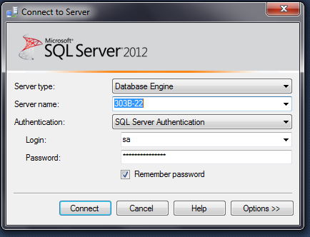

2. Create Database

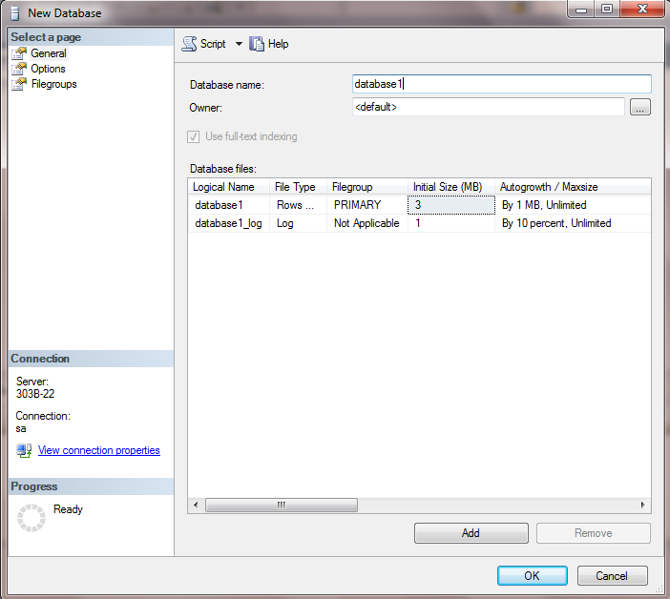

3. Create New Table in your database

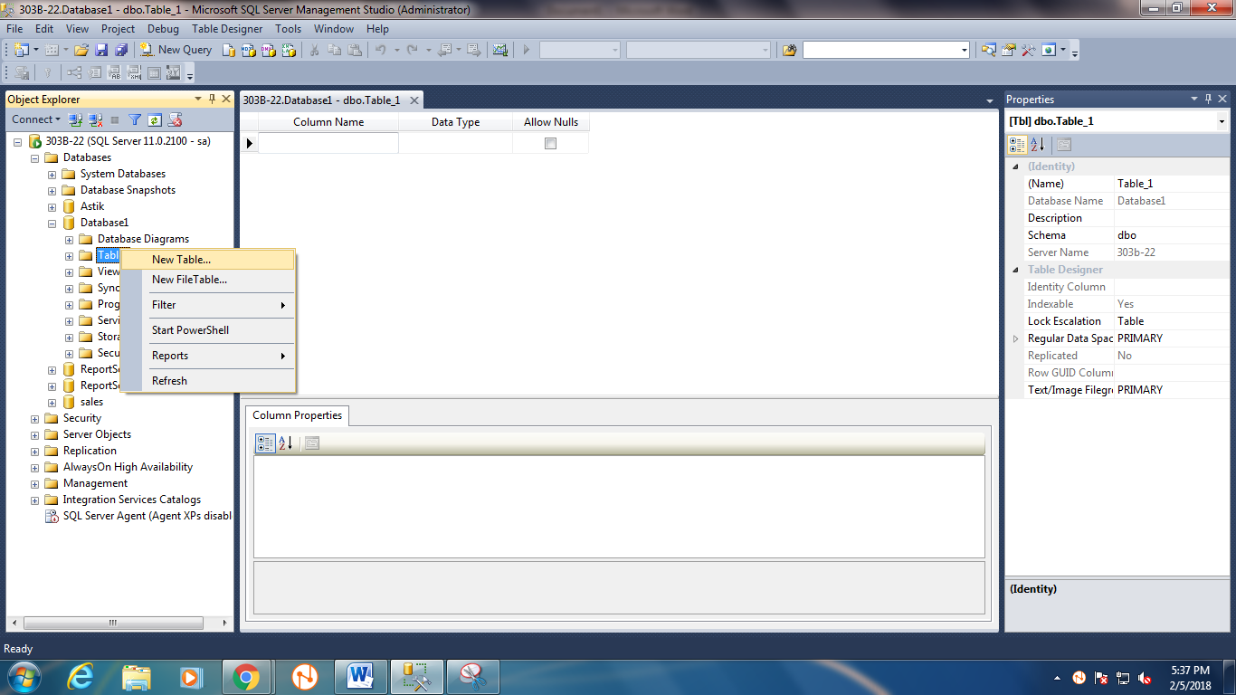

4. Entering data in PRODUCT table

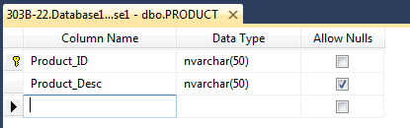

5. Entering data in REGION table

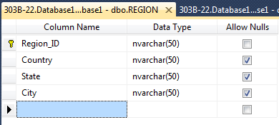

6. Entering data in CUSTOMER table

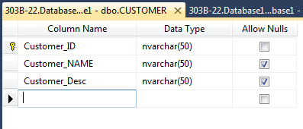

7. Entering data in TIME table

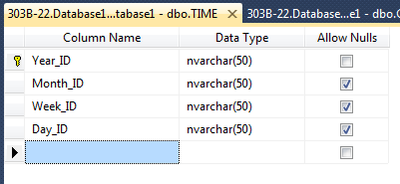

8. Entering data in FACT table

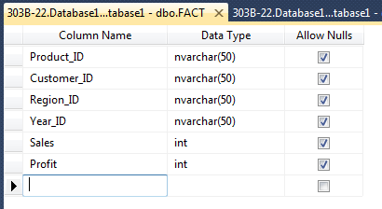

9. Create new database diagram

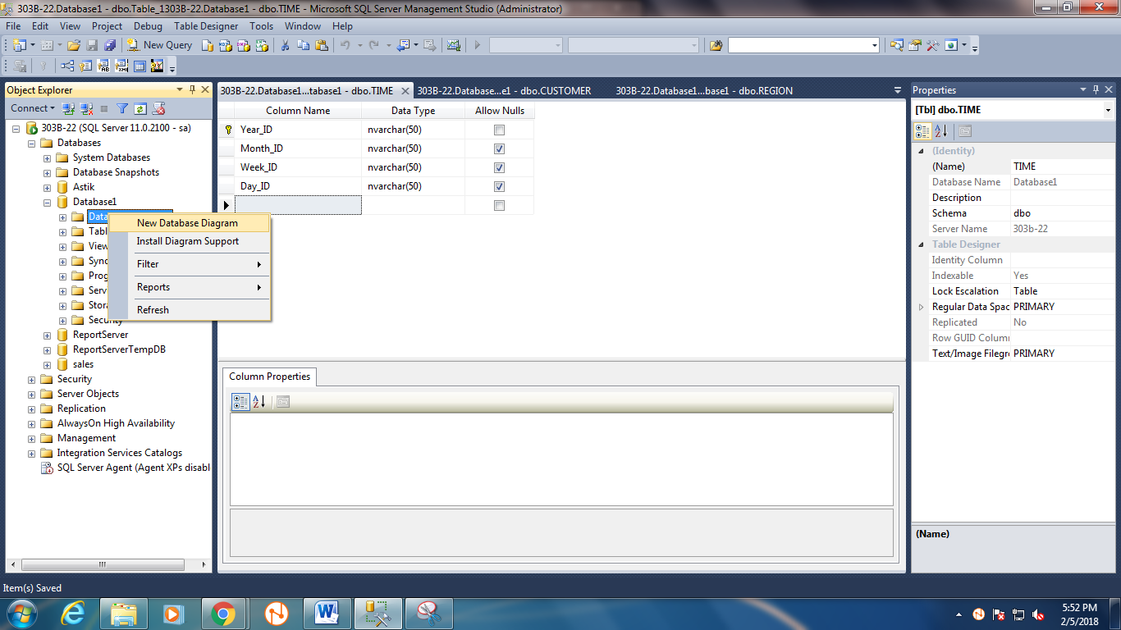

10. Add your all table

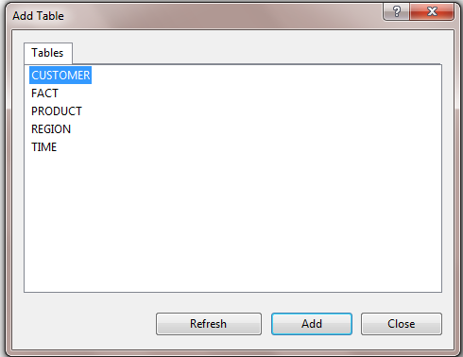

11. after add all tables it will look like this

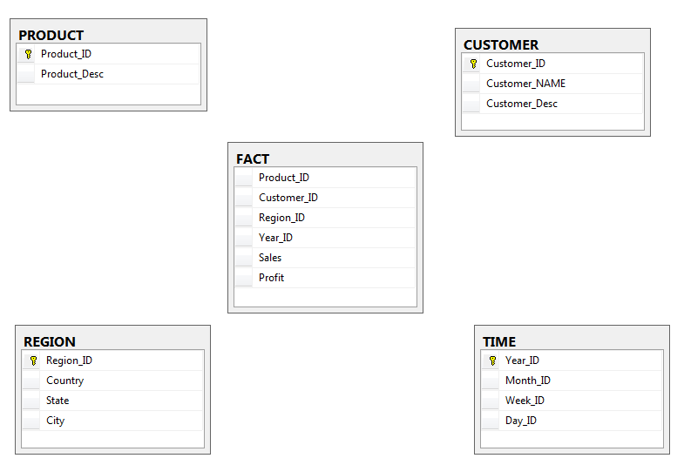

12. now connect the tables with fact table

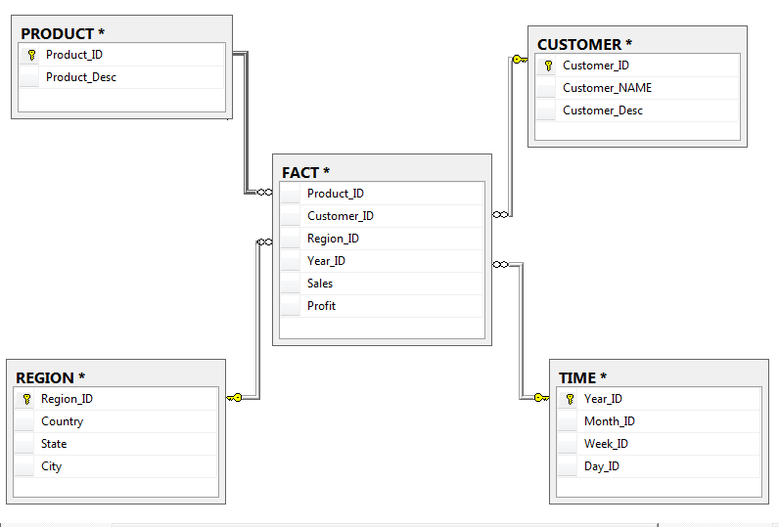

13. Enter data in tables

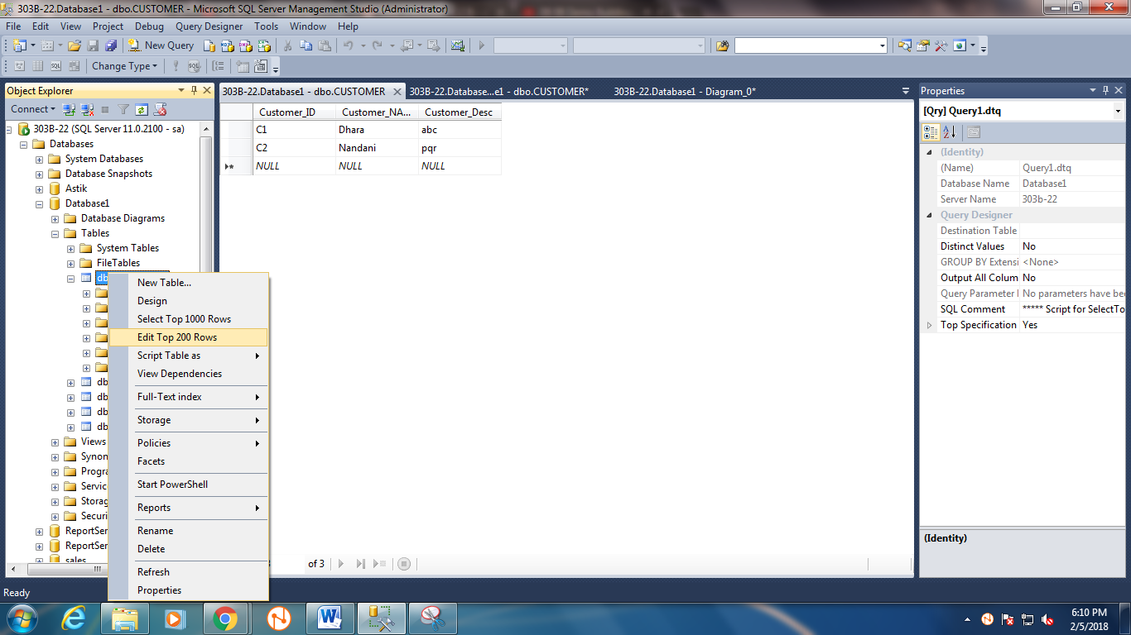

CUSTOMER table

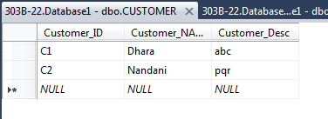

REGION Table

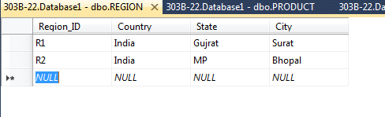

PRODUCT Table

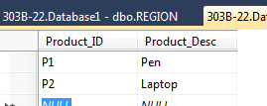

TIME Table

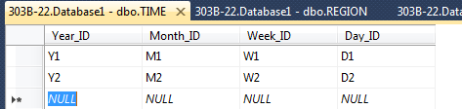

FACT Table

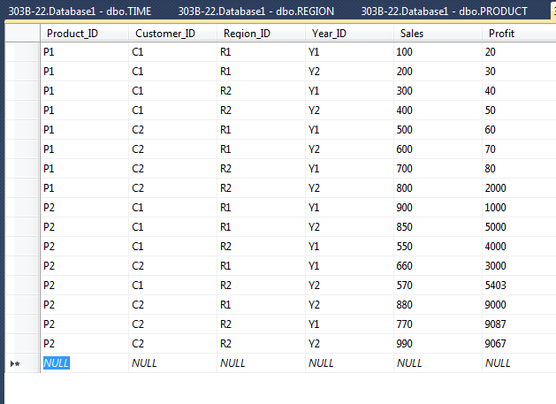

14. Setting up Microsoft Visual Studio

Creating the project:

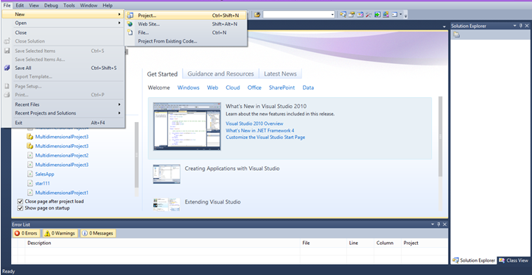

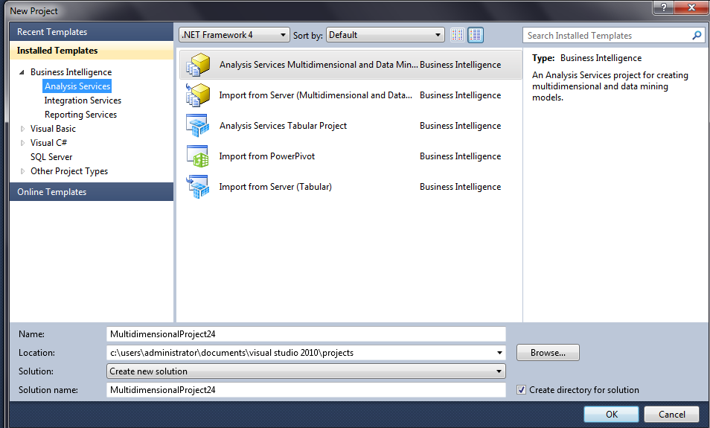

Creating the data source:

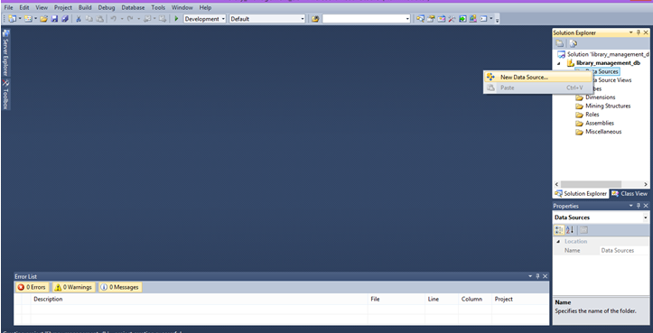Welcome data source wizard

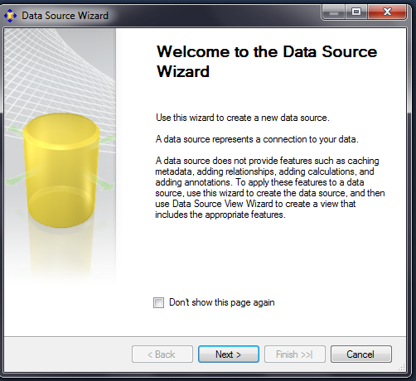

Connect to the database server then click ok

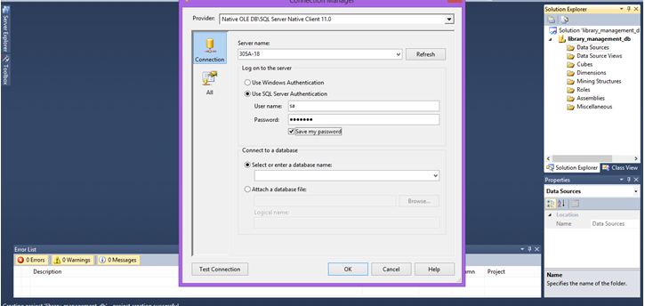

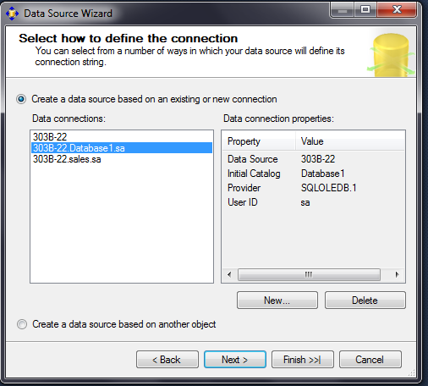

Select the option as shown in next figure and click on the next

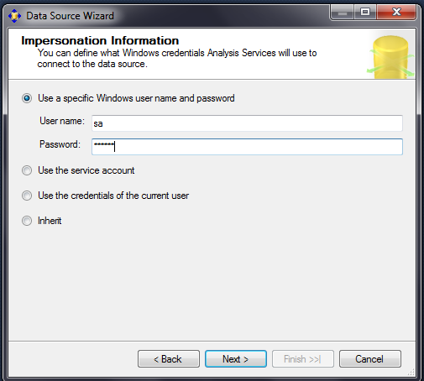

Click on finish

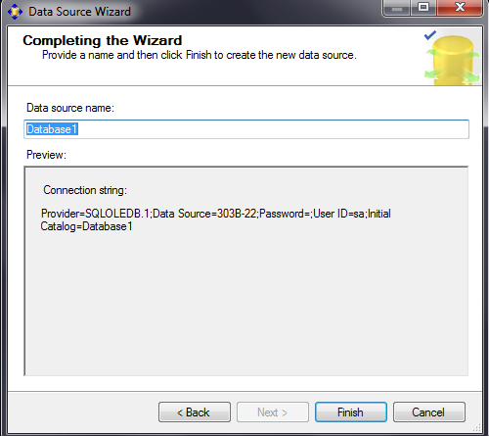

Creating the data source view:

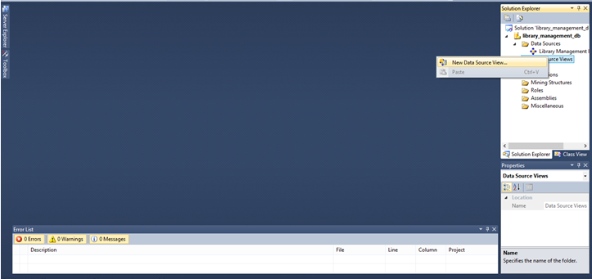

Welcome page of data source view

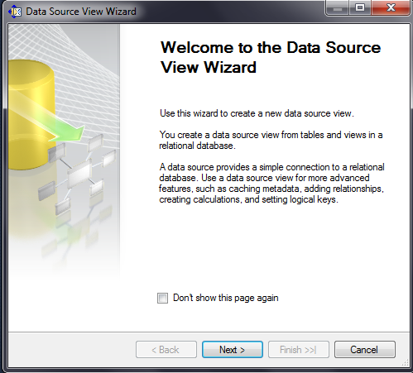

Select data source from data source view wizard

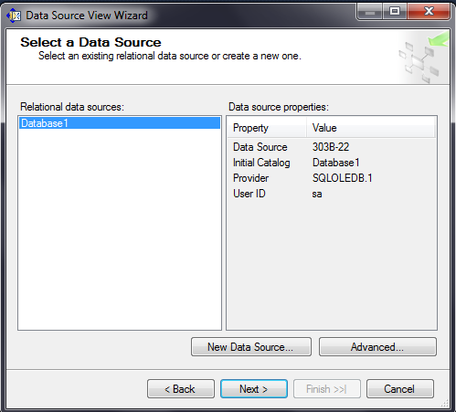

Select all table except system diagrams table

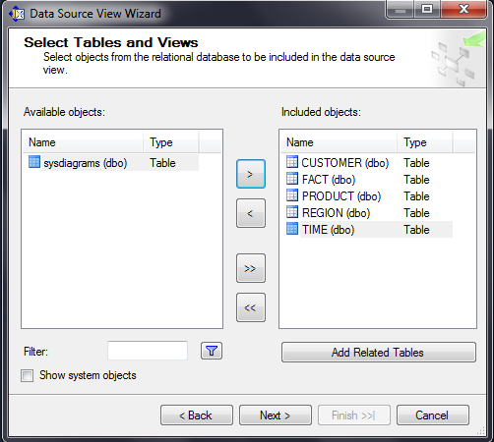

It will show the data source view name and table, click on finish

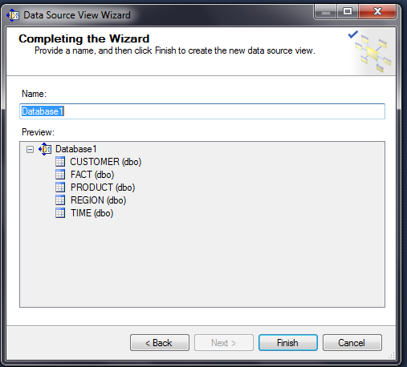

It will show the database diagram as shown in figure

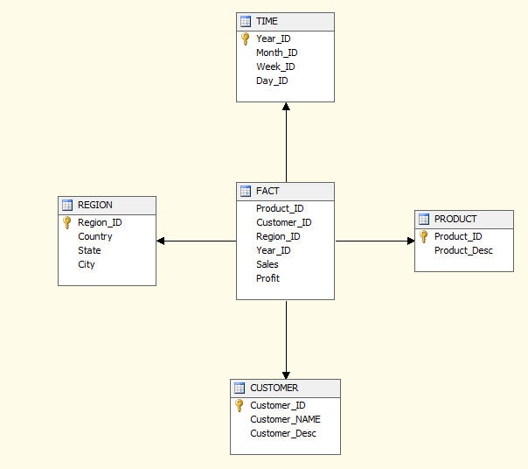

Adding the datacube

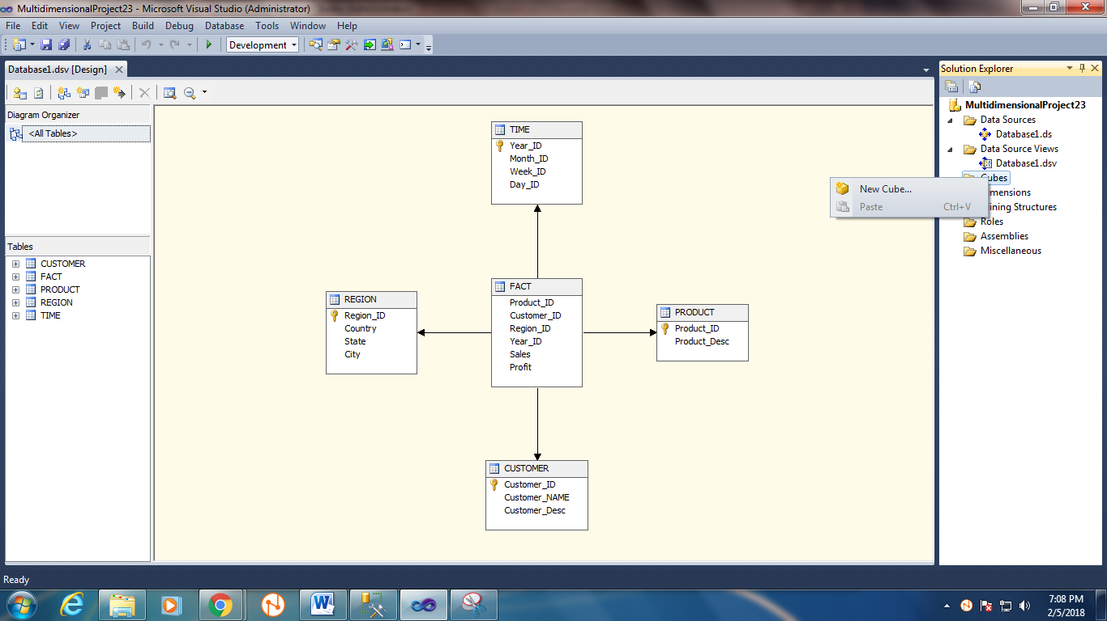

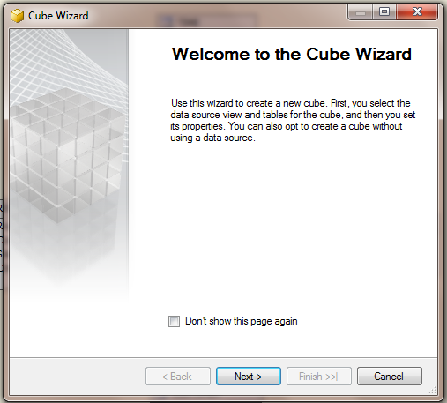

Select all tables for cube and click on next

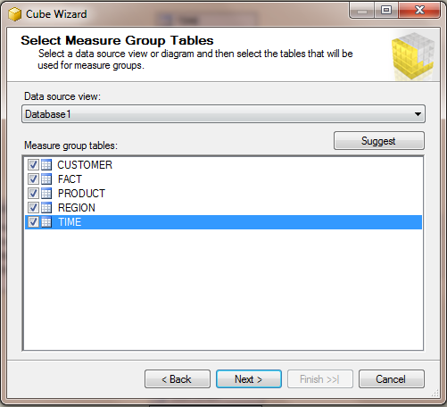

Select all dimensions from all table and click on next

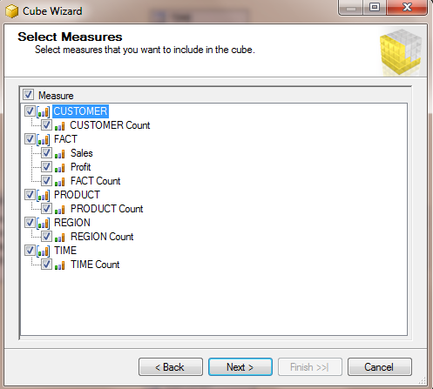

Select the added table and click on next

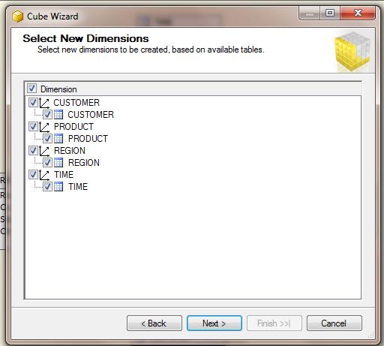

Click on finish

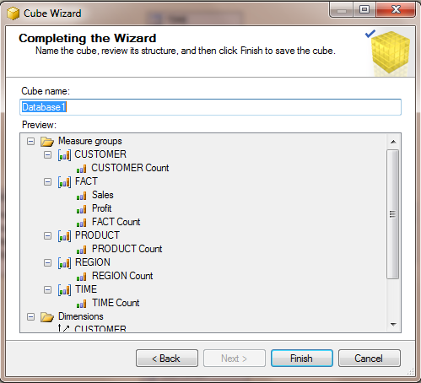

Processing the data cube

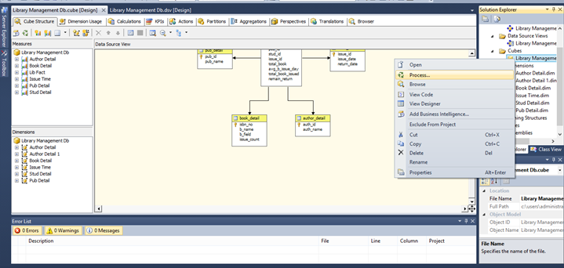

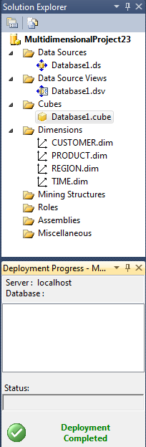

Click on the run

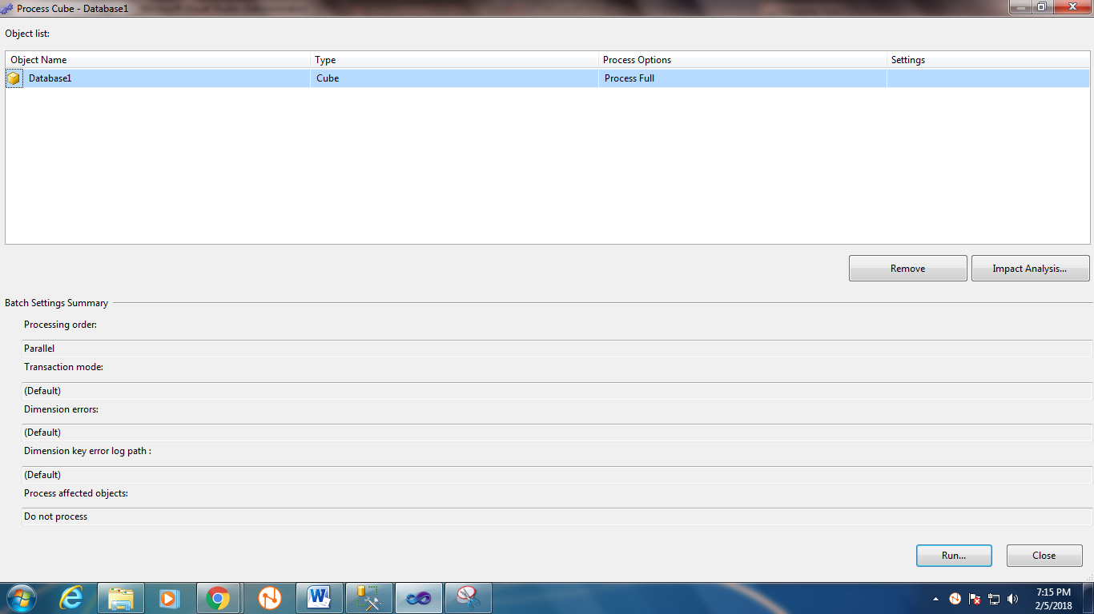

Running will be successful, click on the close button.

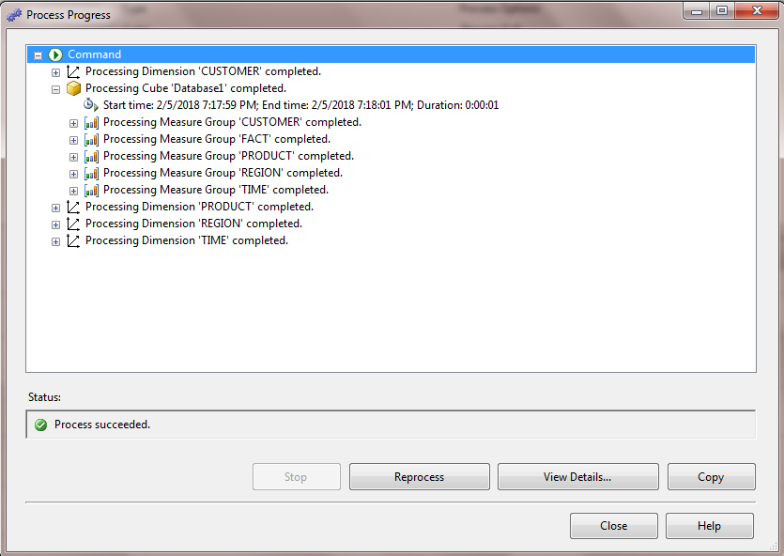

16. Processing the cube

i) Roll up, Drill Down, Slice, Dice

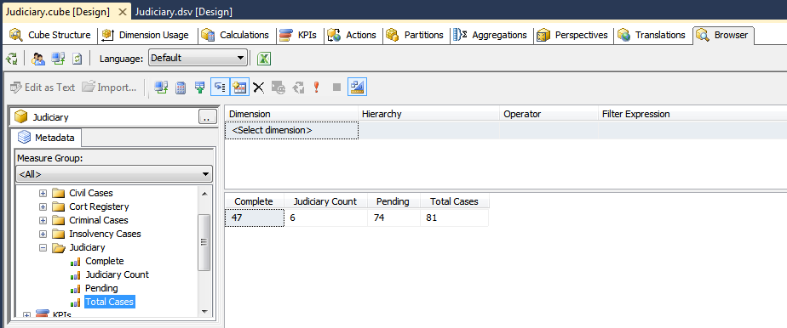

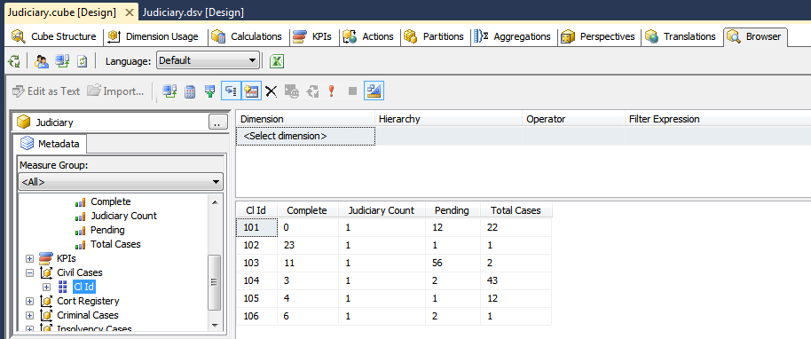

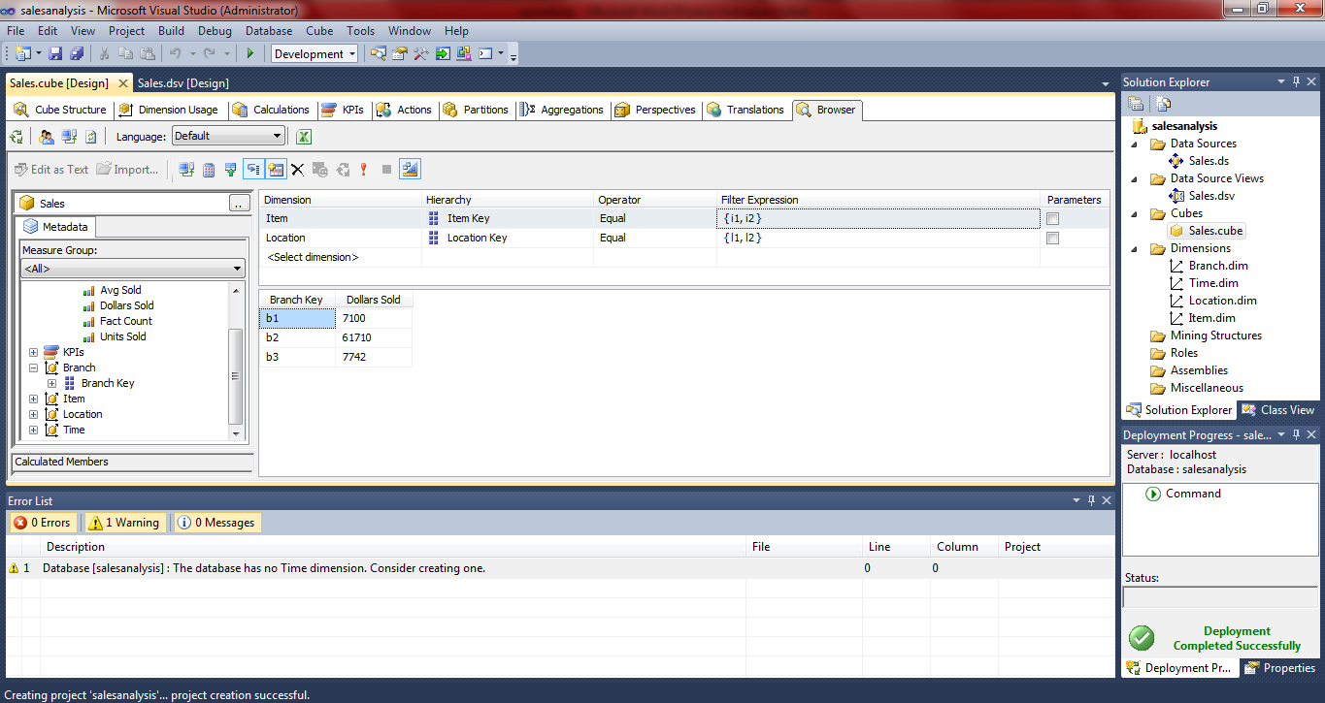

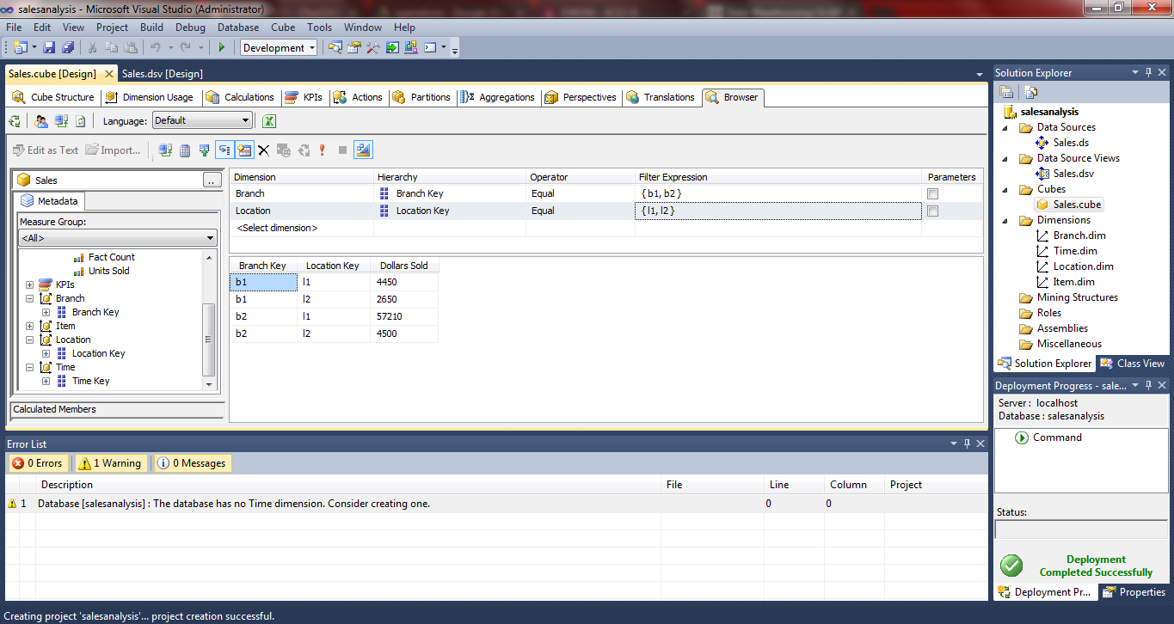

**Conclusion:** Processing of a criminal case database using the various OLAP operations.

**Practical-2**

**Aim:** Introduction to R programming.R-GUI, Rstudio –Basic working and Commands.

**Software Requirement:** R GUI

**Theory:**

R is a programming language and software environment for statistical analysis, graphics representation and reporting. R was created by Ross Ihaka and Robert Gentleman at the University of Auckland, New Zealand, and is currently developed by the R Development Core Team.

R is freely available under the GNU General Public License, and pre-compiled binary versions are provided for various operating systems like Linux, Windows and Mac. This programming language was named **R**, based on the first letter of first name of the two R authors (Robert Gentleman and Ross Ihaka), and partly a play on the name of the Bell Labs Language **S**.

Evolution of R:

R was initially written by **Ross Ihaka** and **Robert Gentleman** at the Department of Statistics of the University of Auckland in Auckland, New Zealand. R made its first appearance in 1993.

* A large group of individuals has contributed to R by sending code and bug reports.
* Since mid-1997 there has been a core group (the "R Core Team") who can modify the R source code archive.

Features of R:

As stated earlier, R is a programming language and software environment for statistical analysis, graphics representation and reporting. The following are the important features of R −

* R is a well-developed, simple and effective programming language which includes conditionals, loops, user defined recursive functions and input and output facilities.
* R has an effective data handling and storage facility,
* R provides a suite of operators for calculations on arrays, lists, vectors and matrices.
* R provides a large, coherent and integrated collection of tools for data analysis.
* R provides graphical facilities for data analysis and display either directly at the computer or printing at the papers.

There are many types of R-objects. The frequently used ones are −

* Vectors
* Lists
* Matrices
* Arrays
* Factors
* Data Frames

There are six data types and they are as follow:

* Logical
* Numeric
* Integer
* Complex
* Character
* Raw

Commands:

* print() – to print any value/string.
* classs() – to get the data type of the variable.
* name() – assign names .
* charToRaw() – convert string into hexa-decimal.

Assigning values to variables:

* variable <- value
* variable = value

**Vectors:** To create vector with one or more element use c() function.

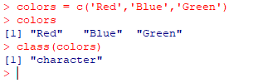

**Lists:** A list is an R-object which can contain many different types of elements inside it like vectors,

functions and even another list inside it.

|  |  |
| --- | --- |
|  | Accessing Elements:    - List_name[index]  - Index starts with 1. |

**Array:** While matrices are confined to two dimensions, arrays can be of any number of dimensions.

The array function takes a dim attribute which creates the required number of dimension.

|  |  |
| --- | --- |
|  | Accessing Elements:  - Array_name[row,column,matrix_no] |

**Factor:**

Factors are the r-objects which are created using a vector. It stores the vector along with the distinct values of the elements in the vector as labels. The labels are always character irrespective of whether it is numeric or character or Boolean etc. in the input vector. They are useful in statistical modeling.

Factors are created using the factor() function. The nlevels functions gives the count of levels.

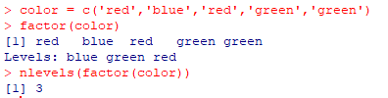

**Matrix:**

The basic syntax for creating a matrix in R is −

matrix(data, nrow, ncol, byrow, dimnames)

Following is the description of the parameters used −

* data is the input vector which becomes the data elements of the matrix.
* nrow is the number of rows to be created.
* ncol is the number of columns to be created.
* byrow is a logical clue. If TRUE then the input vector elements are arranged by row.
* dimname is the names assigned to the rows and columns.

|  |  |
| --- | --- |
|  | Accessing Elements:    Matrix_name[row, column] |

Matrix Operations:

|  |  |
| --- | --- |
| Multiplication:  Saf | Addition:    Subtraction: |

**Data Frames:**

Data frames are tabular data objects. Unlike a matrix in data frame each column can contain different modes of data. The first column can be numeric while the second column can be character and third column can be logical. It is a list of vectors of equal length. Data Frames are created using the data.frame() function.

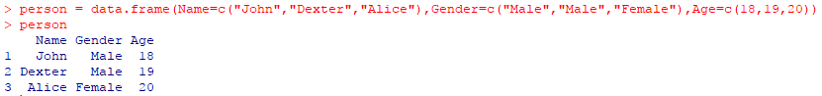

**Conclusion:** In this practical we have learned about basic of R language and its implementation using

R GUI.

**Practical-3**

**Aim:** Write a program to Perform various steps of preprocessing on the given relational database/ warehouse/ files.(Data Preparator)

* **Data Cleaning**

Data cleaning facilities include character removal, text replacement, and date conversion.

* **Data Import/Export**

Data Preparator can be used to import data from a database and export them to a file and vice versa.

* **Data Integration**

Two operators, Append and Merge, can be used to combine data from different data sources.

* **Data Reduction**

Data reduction can be achieved using sampling and record selection.

* **Data Transformation**

Data Preparator can be used to pre-process data for data mining. It transforms training data using a series of transformations and in the process creates a model which can be used to transform corresponding test/execution data.

Data Preparator provides many operators for transforming data.

* **Data Visualization**

Data visualization can be performed using a variety of statistical plots.

Main Window

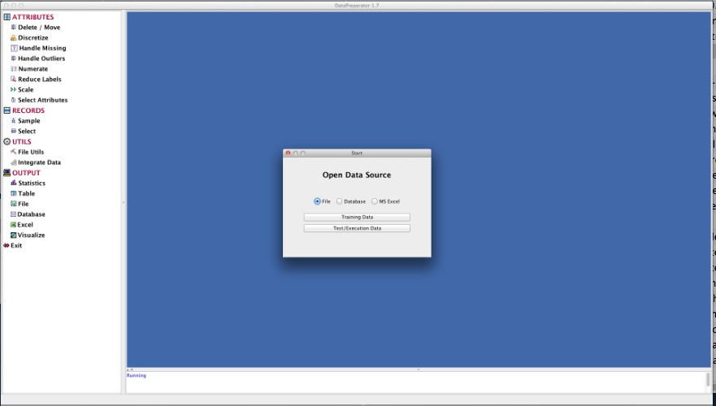

The initial window. Open a data source from the Start dialog, then drag operators from the list on the left to the panel on the right.

**Operator Tree**

An operator tree is a tree of operators (preprocessing transformations) that are to be applied to the data. The nodes of the tree represent the operators and the links between the nodes show dependencies between the operators. The root of the tree --- the *Data* node --- is created automatically after opening a data source. With each node is associated an operator dialog which is displayed when the user clicks on the gray area of the node. Operators are initialized by entering required details into operator dialogs.

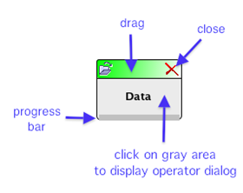

## Creating Nodes

To create a new node, drag an operator name from the list of names on the left hand side of the main window and drop it on the display pane on the right hand side

## Connecting Nodes

To link two nodes by an arrow, press the mouse button on the gray area of the first node and drag the mouse to the second node. Release the mouse button on the gray area of the second node.

## Moving Nodes

To move a node to a different location on the display pane, press the mouse button on the coloured bar at the top of the node and drag the node to the desired location.

## Displaying Operator Dialog

After creating a new node, the node color is purple. Click on the purple area to display the associated operator dialog and enter the desired values. Press OK, Execute or Close as appropriate. This marks the node as processed and changes its color to gray. Clicking on the gray area displays the dialog.

## Types of Nodes

There are five types of nodes, distinguished by the colour of the bar at the top of the node icon.

* Greennode is the Data node. It is the root of the operator tree. There can be only one green node.
* Blue nodes are preprocessing nodes that will be included in the corresponding Model Tree. They represent the transformations that will also be performed on the test or execution data sets.
* Rednodes are output nodes that display or save results. They cannot have descendants.
* Yellow nodes are file utils nodes which can only have the Data node or another File Utils node as the parent node. However, they can have other nodes as descendants.
* Gray nodes are preprocessing nodes that will not be included in the corresponding model tree. There is only one gray node: Sample. Sampling would not be meaningful for test or execution data sets.

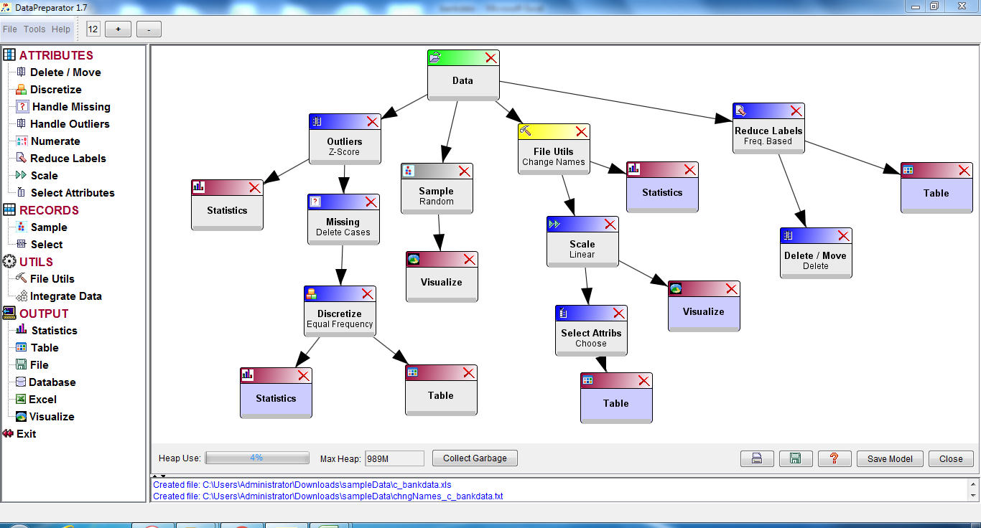

**1.Attribute Operator**

**1) Outlier**

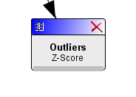

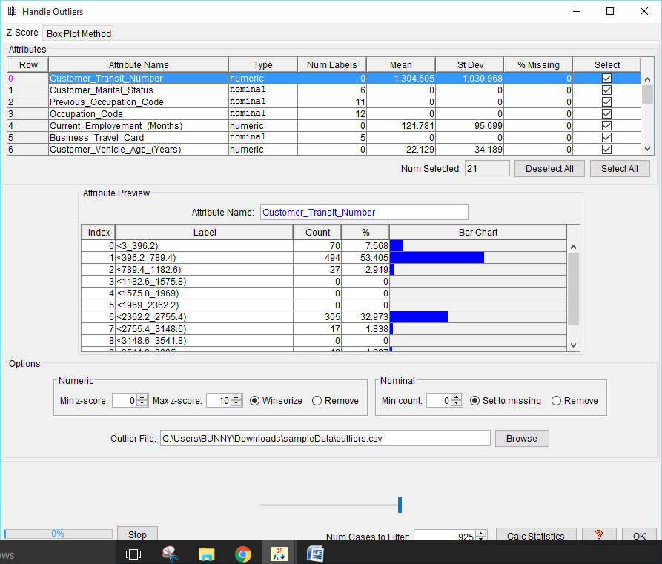

# Z-Score Method

This operator uses the Z-Score method to handle outliers in numeric attributes, and a frequency based approach to handle outliers in nominal attributes.

## Numeric Attributes

The Z-Score method uses the zscore statistic defined as:

zscore = (value - mean) / standard deviation

It gives the number of standard deviations a value is above or below the mean. An outlier is a value that has zscore above a specified upper limit or below a specified lower limit.

There are two options for dealing with outliers:

1. Winsorize (replace outliers with the values corresponding to the specified zscore limits).
2. Remove the records containing outliers from the data set.

## Nominal Attributes

In a nominal attribute, a value (label) that has a very low frequency of occurrence is considered to be an outlier. There are two options for dealing with outliers:

1. Replace outliers by the missing value symbol.
2. Remove the records containing outliers from the data set.

## Saving Outliers to a File

The operator also saves records containing outliers to a file. The outlier file is created when data are filtered through a path containing the Outliers node. The filtering process must be initiated from a descendant node. For example, a Statistics node below the Outliers node.

## Using the Operator

1. Select the attributes for which to handle outliers by checking check boxes in the Select column.
2. Select options for numeric attributes.
   * Enter the minimum and maximum z-scores.
   * Specify how to handle outliers in numeric attributes (winsorize or remove from the data set).
3. Select options for nominal attributes.
   * Set the minimum frequency for the values of nominal attributes in the Min count spinner.
   * Specify how to handle outliers in nominal attributes (replace with missing value symbol or remove from the data set).
4. Compute statistics. Set the number of cases in the Num Cases to Filter spinner and press the Calc Statistics button. This updates the mean, standard deviation and other statistics required by the operator.
5. Click OK.

**02) Delete/Move Attributes**

This option allows the user to remove attributes from the data or to move selected attributes either to the leftmost or to the rightmost position in the data set.

For details see:

* Delete
* Move

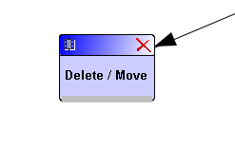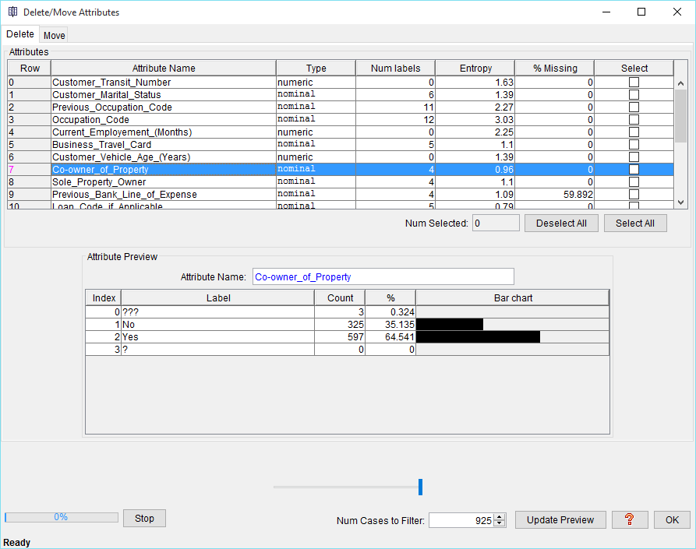

**3). Discretize Numeric Attributes**

Discretization transforms numeric (continuous) attributes to nominal (categorical or discrete) attributes.

The range of a numeric attribute is divided into intervals and each interval is given a label. Attribute values are replaced by the labels of the intervals into which they fall.

The following discretization methods are currently available:

1. Equal Width Discretization
2. Equal Frequency Discretization
3. Equal Frequency Discretization from Grouped Data
4. Defined Cut Points

# Equal Width Discretization

Equal width discretization divides the range of a numeric attribute into a specified number of intervals of equal width.

Interval width is computed by dividing the attribute range by the number of interval

# Equal Frequency Discretization

Equal frequency discretization divides the range of a numeric attribute into a given number of intervals containing equal (or nearly equal) number of values.

# Equal Frequency Discretization from Grouped Data

This operator creates a specified number of approximate equal-frequency intervals. It computes interval cut points by interpolating grouped data in frequency histograms. This is a standard statistical technique for computing quantiles from grouped data. Here the intervals are equivalent to quantiles.

The main advantage of this method is that it does not require sorting of attributes. The disadvantage is that the resulting intervals are only approximate.

# Defined Cut Points

This operator allows you to discretize numeric attributes manually by entering the desired cut points.

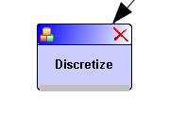

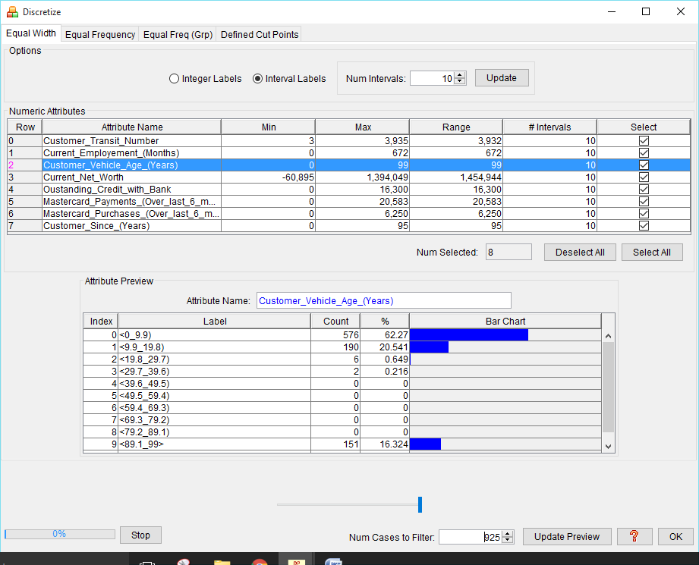

# 4) Handle Missing Values

This command provides operators for handling missing values. Currently the following methods are available:

1. Delete Cases
2. Remove Attributes
3. Impute Values
4. Predict from Model
5. Create Missing Value Patterns

# Delete Cases

This method removes cases containing missing values from the data set. This is a commonly used approach referred to as listwise deletion or casewise deletion.

1. **Remove Attributes**

This operator removes attributes containing missing values from the data set.

# Impute Values

This operator replaces missing values with imputed values. It uses single-value imputations where all missing values in an attribute are filled with the same imputed value. The problem with this approach is that it can lead to bias. Commonly used imputations are the attribute mean or median for numeric attributes, and the mode for nominal attributes.

# Predict From Model

This operator replaces missing values with values predicted by a prediction model.

# Create Missing Value Patterns

This operator adds new attributes (missing value patterns) to the data set. It creates a new two-valued (dichotomous) variable for each selected attribute containing missing values. The values of the new variable represent two possible states: "value is present" and "value is missing".

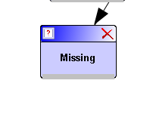

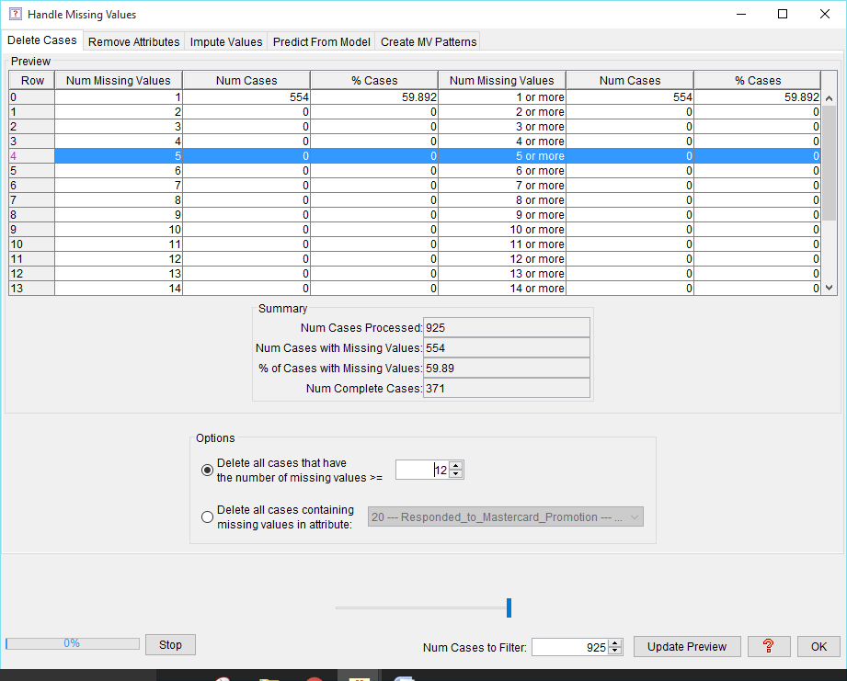

**5. Numerate Nominal Attributes**

This operator transforms nominal (categorical) attributes to numeric attributes.

Two methods are provided:

1. Create Binary Attributes
2. Replace Labels by Label Indices .

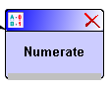

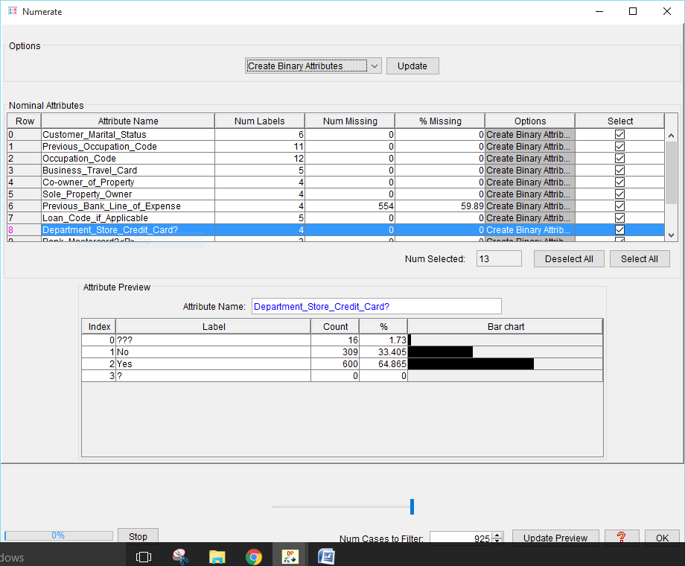

# 6. Reduce Number of Labels

Some data sets contain nominal (categorical) attributes with large number of distinct values (labels or categories). It may be necessary to reduce the number of labels for the reasons of computational efficiency.

This operator reduces the number of labels of nominal attributes by keeping up to a given number of most frequent labels and creating a new label from all the remaining labels.

If a nominal attribute has more labels than the specified maximum number *m*, then the first *m-1* labels with the largest frequencies will be retained and one new label will be created out of all the remaining labels.

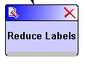

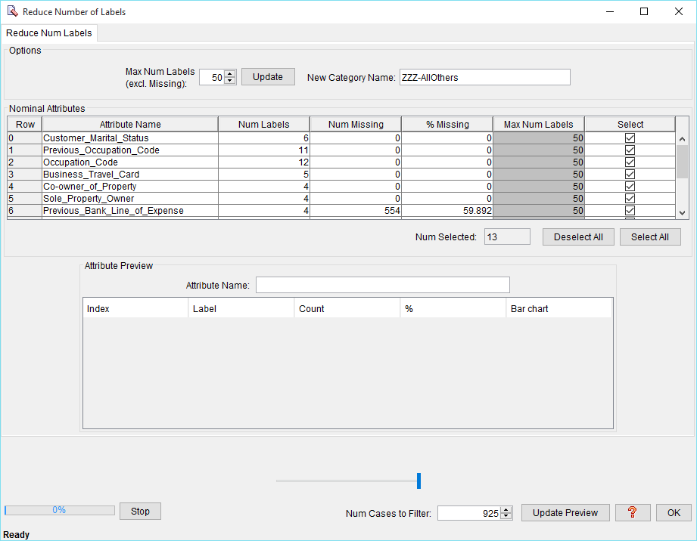

**7.Scale Numeric Attributes** This command provides operators for scaling (or normalizing) numeric attributes. Scaling is required for data mining algorithms that accept only attribute values within certain ranges. For example, neural networks, clustering, nearest neighbour among others. Scaling is also needed to prevent bias when attributes have very different ranges (e.g., age and salary). Currently the following scaling methods are provided:

1. Linear
2. Decimal
3. Hyperbolic Tangent
4. Soft-Max
5. Z-Score

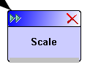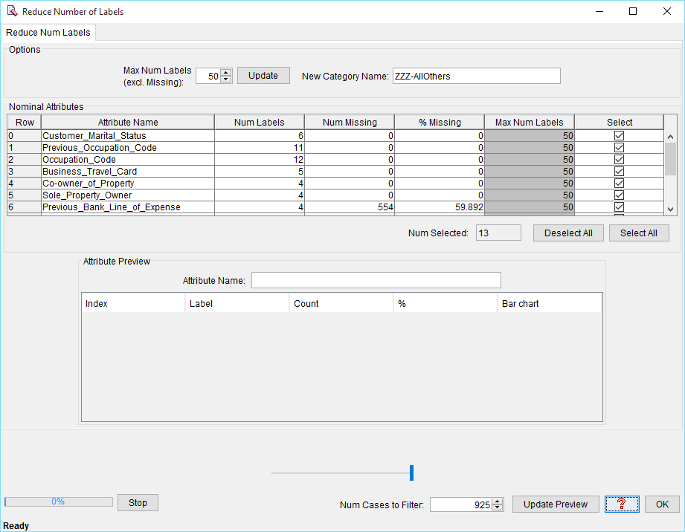

**Select Attributes**

This command selects a subset of attributes. The following methods are currently provided:

1. Manual Selection
2. Mutual Information Selection
3. Robust Mutual Information Selection

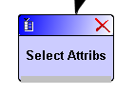

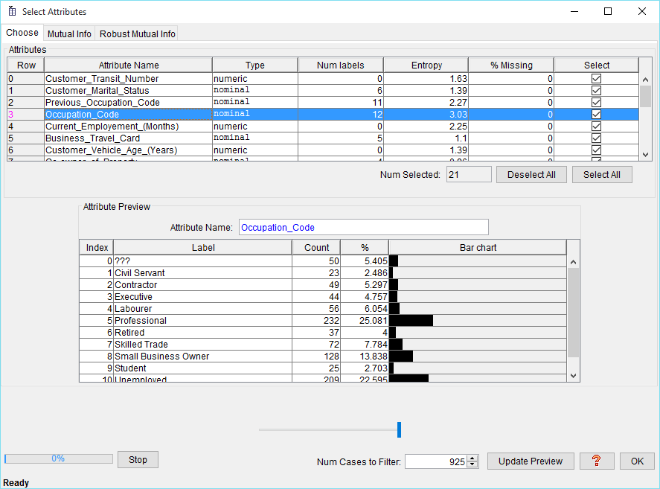

**2. Record operator**

**1. Sample**

This operator creates a sample from the data set. The following sampling methods are provided:

1. Random
2. One in K
3. First K

Random sampling selects cases at random according to a given percentage. One-in-K sampling selects every K-th case. First-K sampling selects the first K cases from the data set.

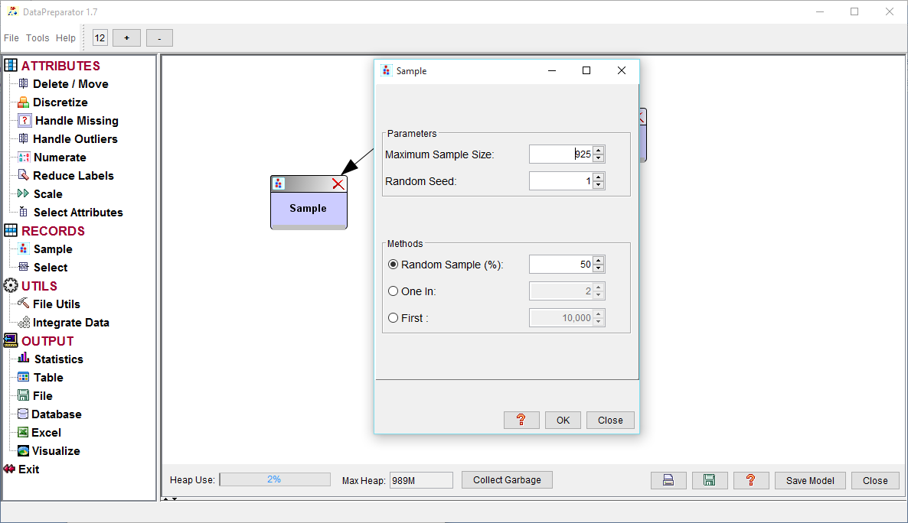

# 2.Select Records

This operator selects records (cases) from the data set, based on a specified key and key values.

## Using the Operator

1. Select either AND or OR radio button.
   * If the AND radio button is selected then a case will be selected only if it contains the selected key values for all the selected keys.
   * If the OR radio button is selected then a case will be selected when it contains the selected key values of at least one selected key.
2. Specify whether the operation is Include or Remove.
   * If the Include radio button is selected then all the cases satisfying the selection criteria will be included in the resulting data set.
   * If the Remove radio button is selected then all the cases satisfying the selection criteria will be removed from the resulting data set.
3. Select a key (key attribute) from the list on the left.
4. Select key values.
   * For a nominal key attribute, select one or more key values from the list on the right. (Press ctrl key and click appropriate rows, then click Add to Selected).
   * For a numeric key attribute, specify the range of values to be selected by entering the minimum value in Target Min and the maximum value in Target Max spinners.
5. Press Add to Selected.

Repeat the steps 3, 4 and 5 above for other key attributes as needed.

1. Click OK.

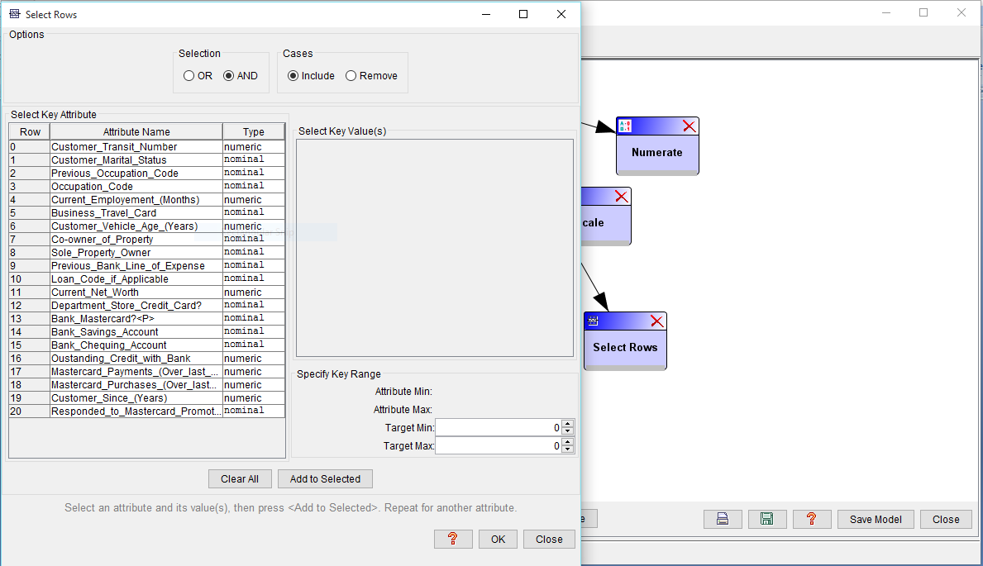

**3.Utils**

**1. File utils**

**1.1Create Data Sets**

This operator partitions the data set into three files:

* Training File
* Test File
* Validation File

# 1.2 Create Missing Values

This operator creates a file containing missing values.

This may be useful when experimenting with algorithms for handling missing values.

**1.3 Append**

The *Append* operator can be used to append cases from a file, a database table or an Excel worksheet to the end of the current data set.

The appended rows and the current data set must have the same number of attributes and the corresponding attributes must be of the same type.

**1.4 Balance**

This operator creates a new file in which the labels of a selected nominal attribute (balancing attribute) have approximately equal frequencies.

Two techniques are provided:

1. Under sampling of Majority Classes
2. Oversampling of Minority Classes

**1.5 Merge**

The *Merge* operator merges a sorted data set with another sorted data set into a single file.

# 1.6 Sort

This operator sorts the data set in ascending or descending order of a specified key attribute and creates a sorted file.

# 1.7 Partition Cases

The Partition operator splits a file into multiple files.

There are three options:

1. Split File into a Specified Number of Files
2. Split File by Attribute Values
3. Split File into 2 Files by Row Number

# 1.8 Add Columns

The Add Columns operator adds (appends) columns from a file, a database table or an Excel worksheet to the right of the rightmost column of the current file. The number of rows in the resulting file is equal to the number of rows in the smaller file.

# 1.9 Change Names

This operator changes the names (identifiers) of selected attributes and/or attribute values (labels). It creates a new file containing the changed identifiers.

# 1.10 Encode

This operator encodes data using phonetic algorithms.

A phonetic algorithm encodes words on the basis of their pronunciation. Similarly sounding words will have similar code.

Two phonetic algorithms are included:

* Soundex Algorithm
* Metaphone Algorithm

**1.11 Join**

* The Join operator joins two files by a common key attribute.
* The rows of the resulting file are created from the rows of two files by joining the rows that have matching values of the key attribute. Both files must be sorted in ascending order of the key attribute.

**1.12 Smooth Columns**

The Smooth Columns operator reduces the number of distinct values of selected numeric attributes by replacing the original values with estimated values.

The following smoothing methods are provided:

1. Bin Average
2. Bin Boundaries
3. Bin Midpoint
4. Rounding

# 1.13 Split Columns

The Split Columns operator splits a file into two files by a specified attribute (column).

The columns with indices less than the specified column index are written to one file and the remaining columns to another file.

# 1.14 Transform Attribute Values

This operator transforms attribute values using several common mathematical functions:

ln(x), log2(x), log10(x), exp(x), sqrt(x), sin(x), cos(x), tan(x), 1/x, x2, x3

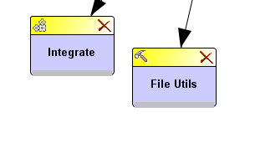

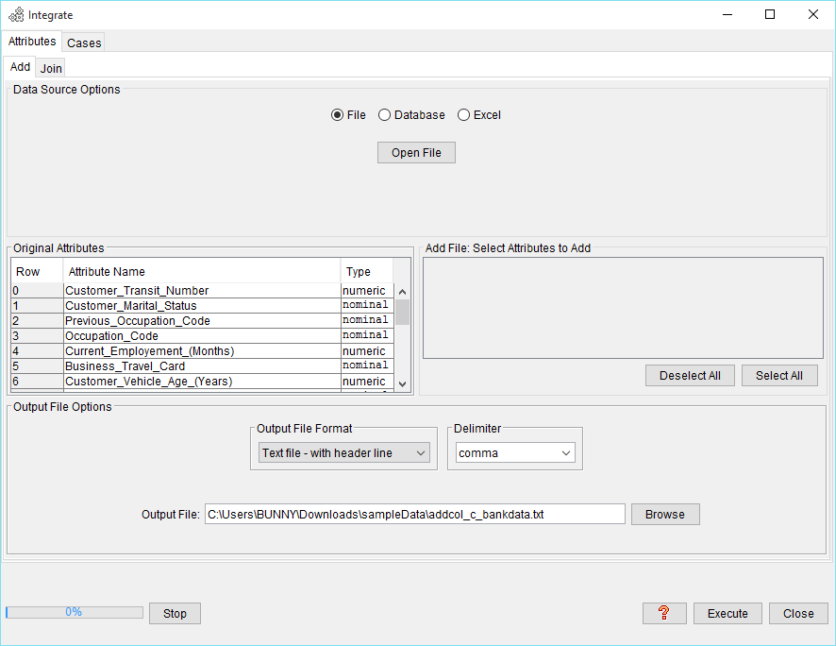

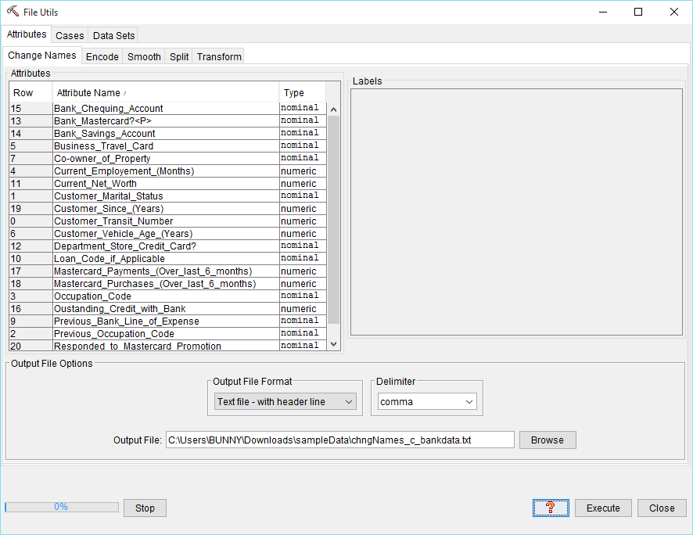

**4. Output**

**1. Statistics**

This operator displays statistical information for the attributes in the data set.

For numeric attributes it shows:

* Minimum
* Maximum
* Range
* Mean
* Standard deviation
* Number of missing values
* Percentage of missing values

For nominal attributes it shows:

* Number of missing values
* Percentage of missing values
* Number of labels

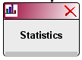

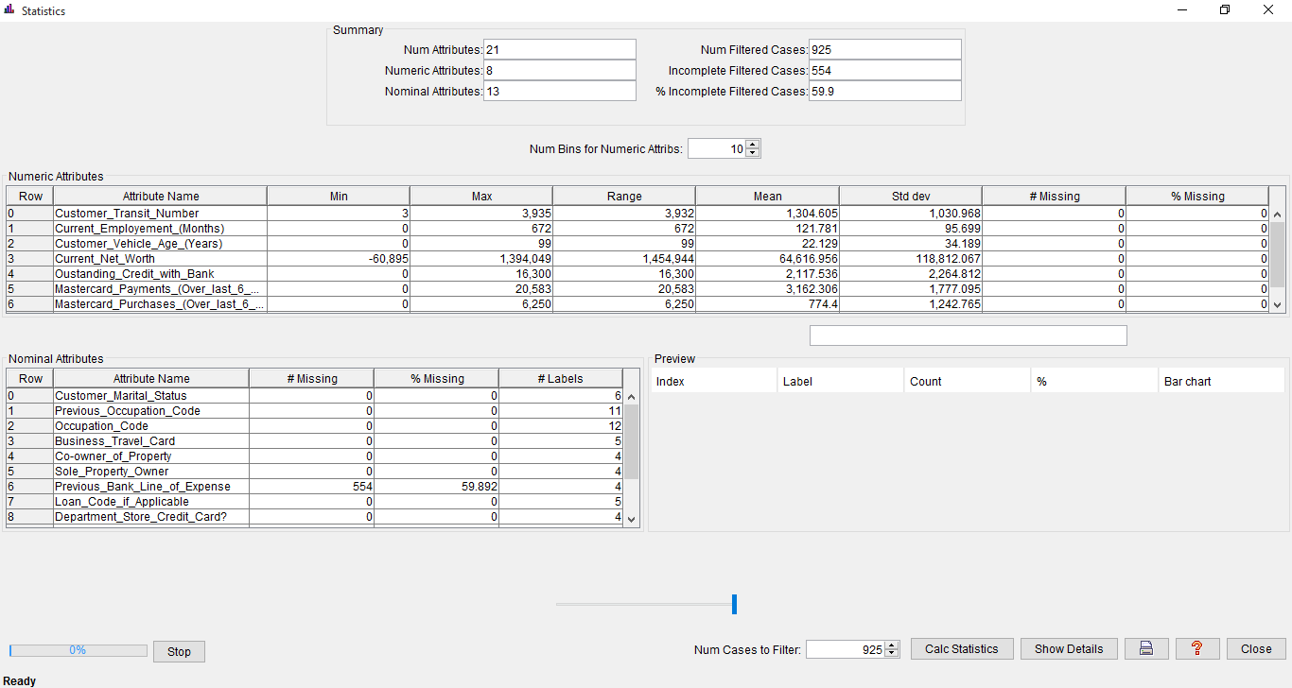

**2. Table**

This operator displays data in a two dimensional table.

It reads one page of data at a time. The page size is set to 100 lines. Initially the first page of *100* lines is loaded.

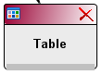

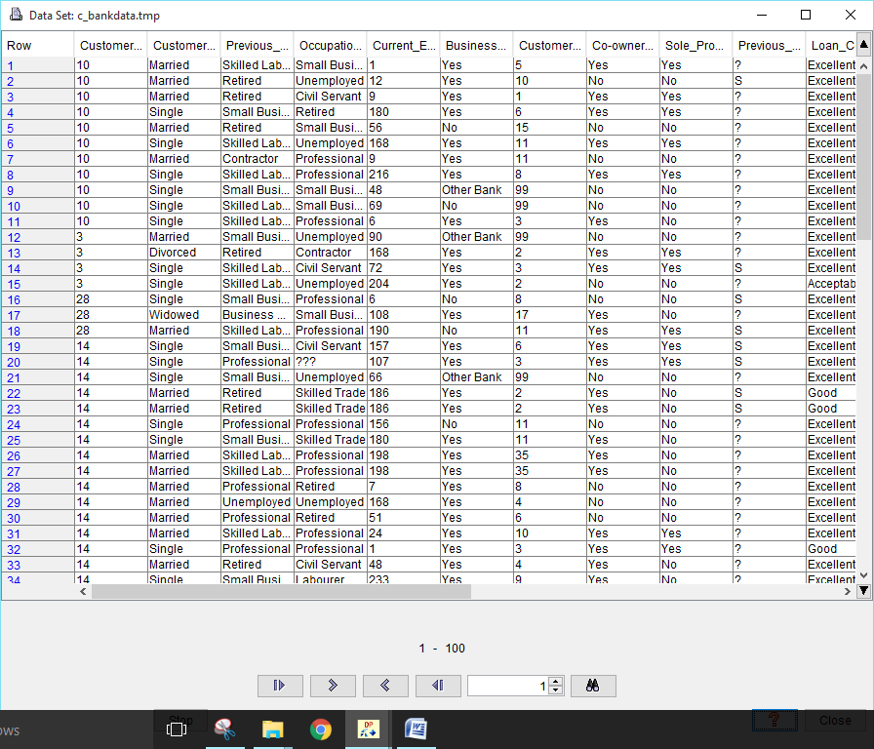

1. **File Output**

This operator saves output to a file.

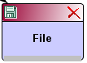

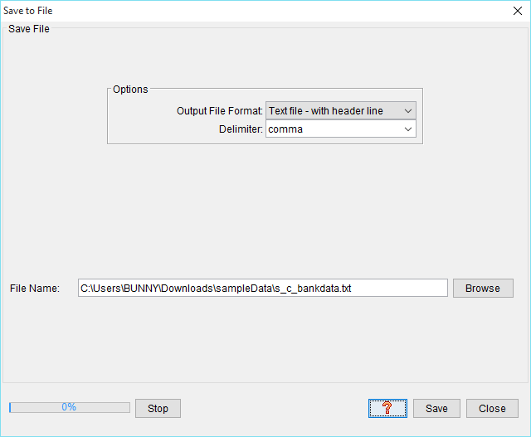

1. **Database Output**

This operator saves output to a database table. It contains two tabs:

1. JDBC/ODBC
2. Other

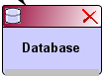

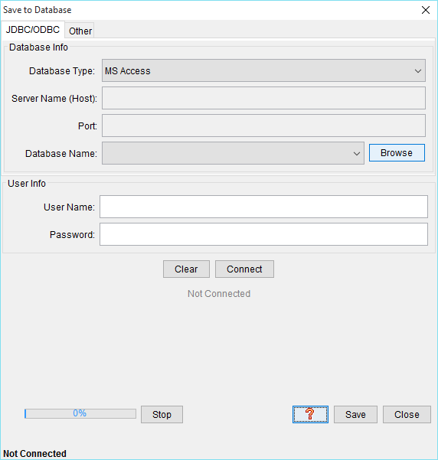

1. **Excel Output**

This operator saves output to an Excel spreadsheet (.xls file). Only up to 256 columns and 65,535 rows are allowed.

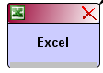

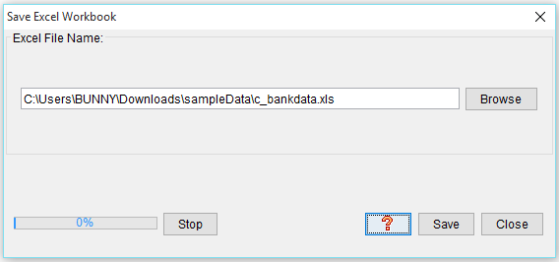

# 6. Visualize Data

This option provides several commonly used visualization techniques. The charts listed below, with the exception of Dependency Tree and Parallel Coordinates, are plotted using the open source library JFreeChart, from http://www.object-refinery.com/.

## Numeric Attributes

1. Univariate Plots
2. Bivariate Plots
3. Conditional Plots
4. Matrix Plots

## Nominal Attributes

1. Univariate Charts
2. Stacked Bar Charts

## Mixed Attributes

1. Dependency Tree
2. Parallel Coordinates

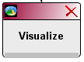

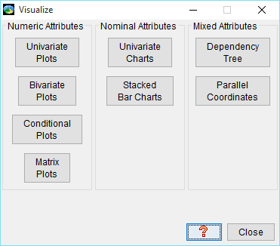

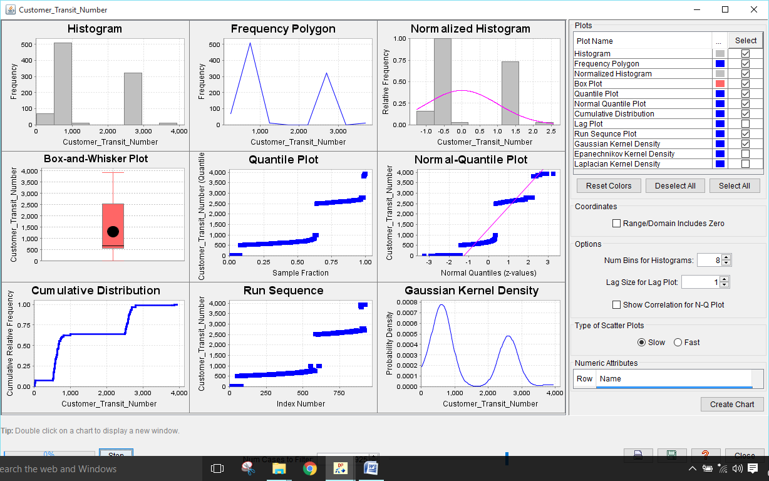

### Performed Steps:

**1.) Starting screen will be look like this.**

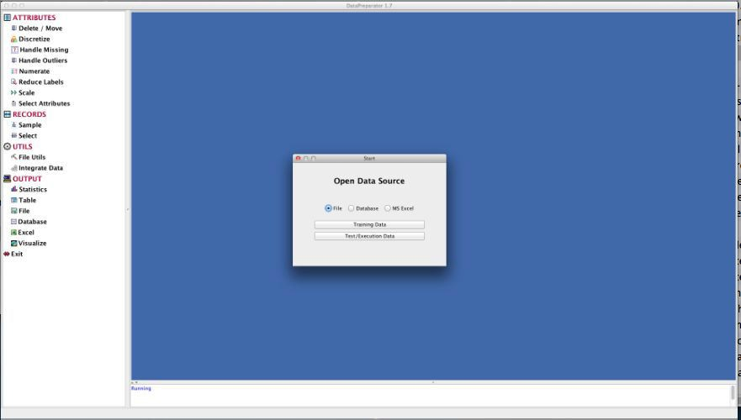

**2.) Select option ‘training data’ with file option.**

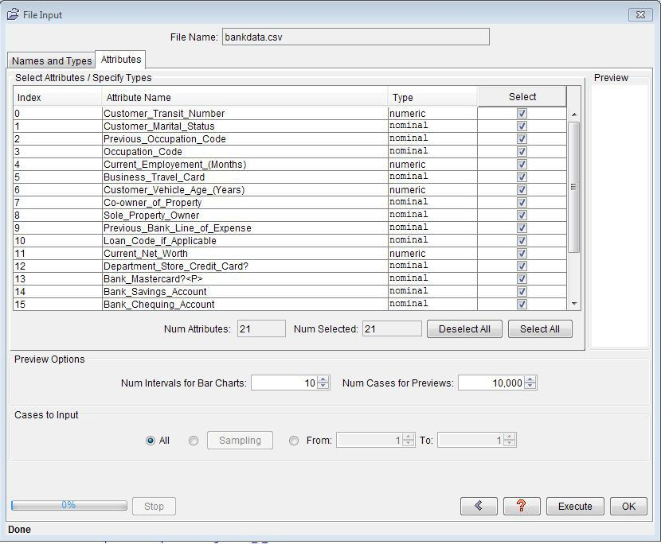

**3.) ‘Handle outliers’ option can be located at left side in the tool.**

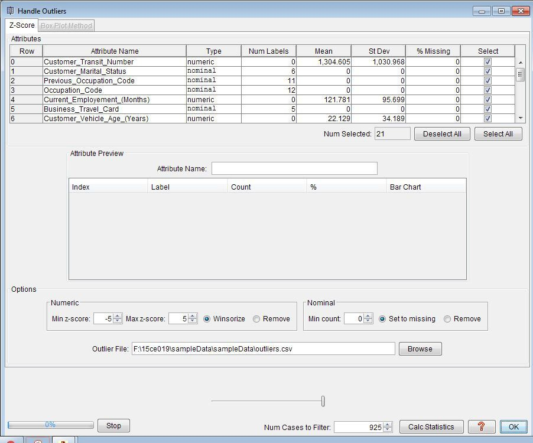

**4.) After adding statistics, this screen will be populated by clicking on the statistics.**

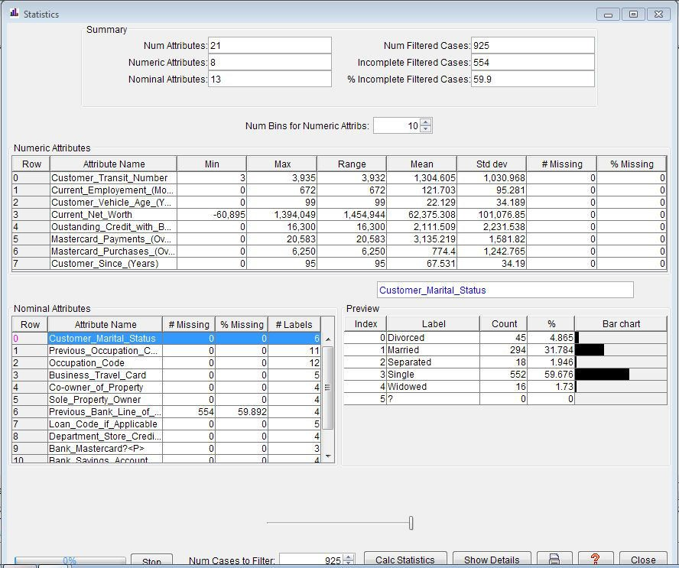

**5.) Handling missing values:**

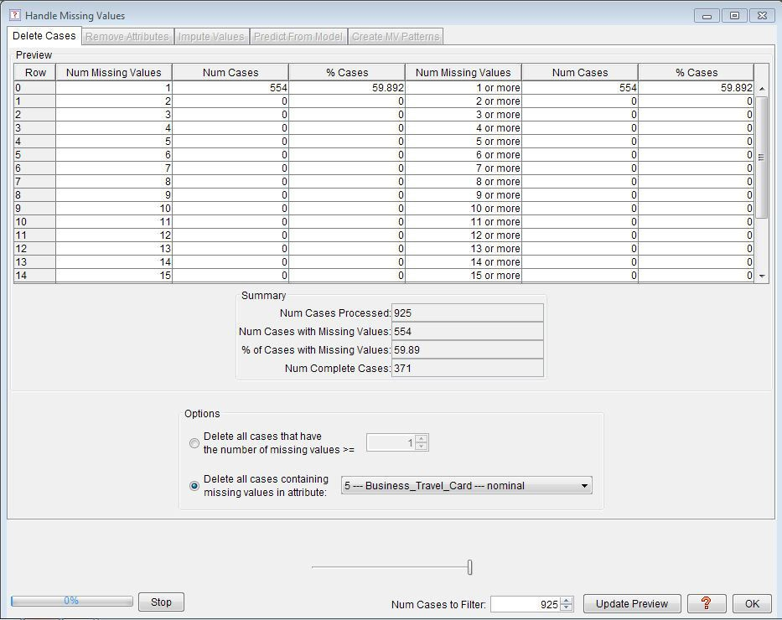

**6.) Discretize:**

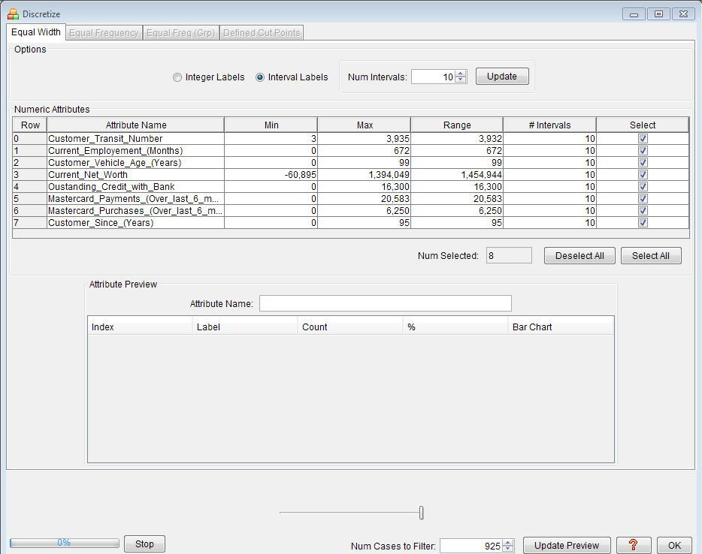

**7.) Operator tree**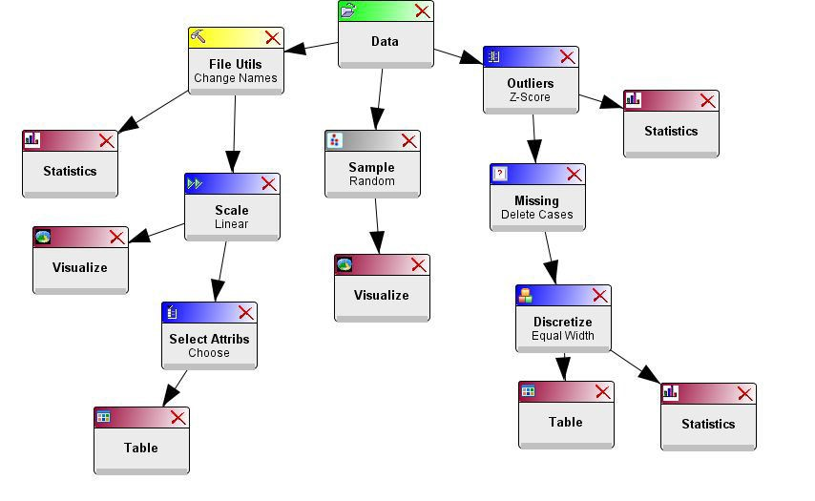

**8.) Various visualization options available here.**

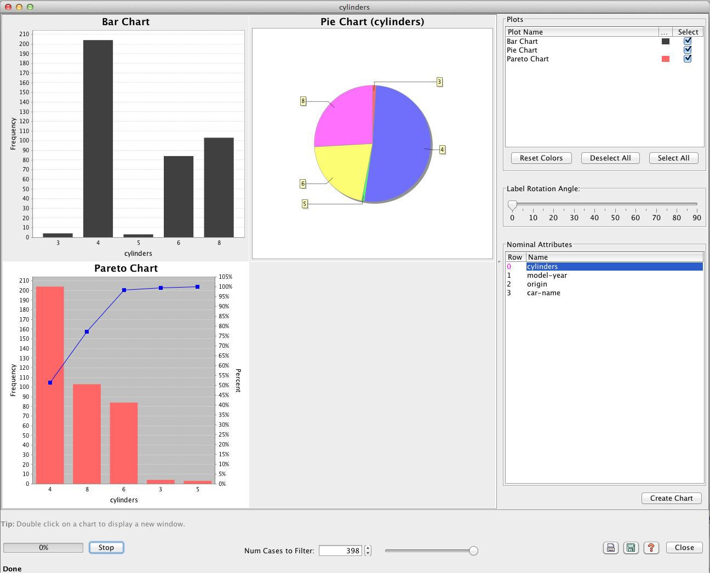

**Conclusion:** In this Practical, we learn about Data Preparator tool.

**Practical-4**

**Aim:** Describing data and its Statistical Analysis Graphically using R Programming.

Perform association rule mining using r programming

**Software Requirement:** R GUI

**Theory:**

R Programming language has numerous libraries to create charts and graphs.

**Pie-Chart**

A pie-chart is a representation of values as slices of a circle with different colors. The slices are labeled and the numbers corresponding to each slice is also represented in the chart.

In R the pie chart is created using the **pie()** function which takes positive numbers as a vector input. The additional parameters are used to control labels, color, title etc.

Syntax: pie(x, labels, radius, main, col, clockwise)

Examples:

library("xlsx")

data <- read.xlsx("BatchB.xlsx" , sheetIndex = 1) print(data)

labels <- c("F","M")

x <- table(data$Gender) pie(x,labels)

library("xlsx") library(plotrix)

data <- read.xlsx("BatchB.xlsx" , sheetIndex = 1)

print(data)

labels <- c("F","M")

x <- table(data$Gender) pie(x,labels)

pie3D(x,labels,explode = 0.1, main = "Pie Chart of Countries ")

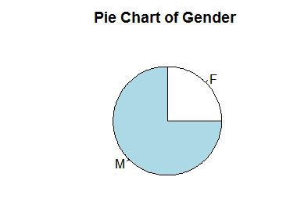

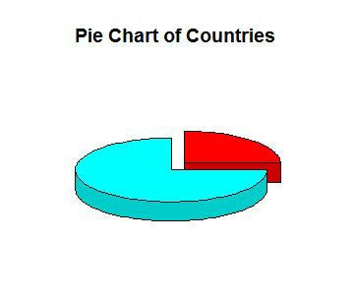

### Barcharts

A bar chart represents data in rectangular bars with length of the bar proportional to the value of the variable. R uses the function **barplot()** to create bar charts. R can draw both vertical and Horizontal bars in the bar chart. In bar chart each of the bars can be given different colors.

Syntax: barplot(H, xlab, ylab, main, names.arg, col) Examples:

library("xlsx") library(plotrix)

data <- read.xlsx("BatchB.xlsx" , sheetIndex = 1) print(data)

labels <- c("F","M")

x <- table(data$Gender)

barplot(x)

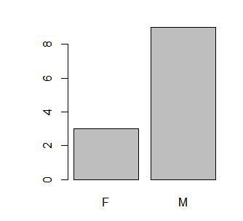

### Line Graphs

A line chart is a graph that connects a series of points by drawing line segments between them. These points are ordered in one of their coordinate (usually the x-coordinate) value. Line charts are usually used in identifying the trends in data.

The **plot()** function in R is used to create the line graph.

Syntax: plot(v, type, col, xlab, ylab)

Examples: library("xlsx") library(plotrix)

data <- read.xlsx("BatchB.xlsx" , sheetIndex = 1) print(data)

labels <- c("F","M")

x <- table(data$Gender)

plot(x, col = “red”, xlab = “Number of students”, ylab = “Gender”, main = “Line Chart”)

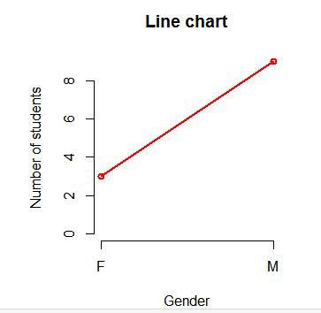

### Boxplots

Boxplots are a measure of how well distributed is the data in a data set. It divides the data set into three quartiles. This graph represents the minimum, maximum, median, first quartile and third quartile in the data set. It is also useful in comparing the distribution of data across data sets by drawing boxplots for each of them.

Boxplots are created in R by using the **boxplot()** function.

Syntax: boxplot(x, data, notch, varwidth, names, main) Examples:

library("xlsx") library(plotrix)

data <- read.xlsx("BatchB.xlsx" , sheetIndex = 1)

boxplot(data, xlab = "Gender", ylab = "Number", main = "Boxplot chart")

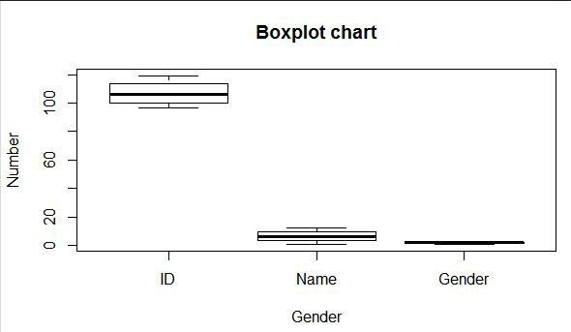

### Histograms

A histogram represents the frequencies of values of a variable bucketed into ranges. Histogram is similar to bar chat but the difference is it groups the values into continuous ranges. Each bar in histogram represents the height of the number of values present in that range.

R creates histogram using **hist()** function. This function takes a vector as an input and uses some more parameters to plot histograms.

Syntax: hist(v, main, xlab, xlim, ylim, breaks, col, border) Examples:

library("xlsx") library(plotrix)

data <- read.xlsx("BatchB.xlsx" , sheetIndex = 1) print(data)

labels <- c("F","M")

x <- table(data$Gender)

hist(x, main = “Histogram of v”, xlab = “Frequency”, ylab = “Weight”, col = “green”, border = “red”)

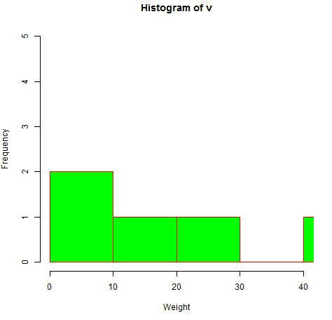

**Association Rule Mining**

Association rule mining is the data mining process of finding the rules that may govern associations and causal objects between sets of items.

So in a given transaction with multiple items, it tries to find the rules that govern how or why such items are often bought together. For example, peanut butter and jelly are often bought together because a lot of people like to make PB&J sandwiches.

Also surprisingly, diapers and beer are bought together because, as it turns out, that dads are often tasked to do the shopping while the moms are left with the baby.

The main applications of association rule mining:

* Basket data analysis - is to analyze the association of purchased items in a single basket or single purchase as per the examples given above.
* Cross marketing - is to work with other businesses that complement your own, not competitors. For example, vehicle dealerships and manufacturers have cross marketing campaigns with oil and gas companies for obvious reasons.
* Catalog design - the selection of items in a business’ catalog are often designed to complement each other so that buying one item will lead to buying of another. So these items are often complements or very related.

1. **Install Package named “arules”** 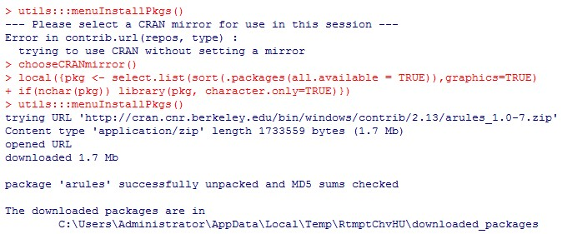
2. **library(“arules”)** 
   * It will Load the package.

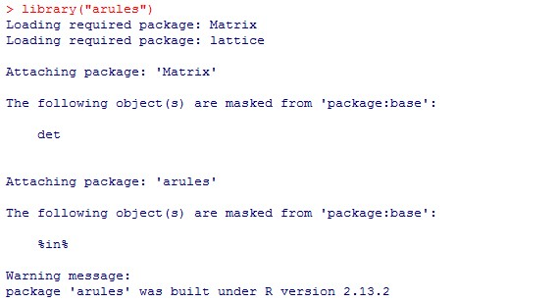

1. **Add file for performing rule mining.**



1. **Summary(groceries)**

It will provide the summary of database named groceries.

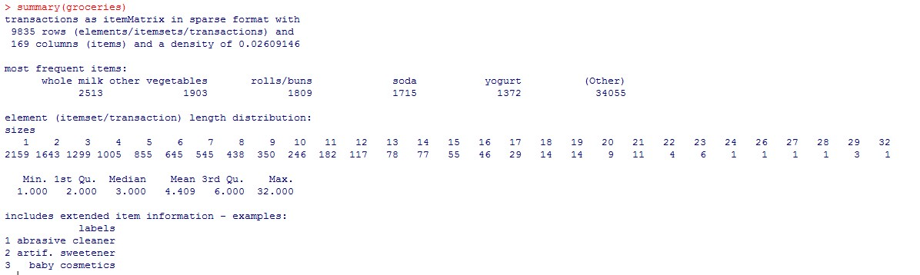

1. **Inspect(groceries[1:5])** 
   * inspect is to summarize all relevant options, plots and statistics that should be usually considered.

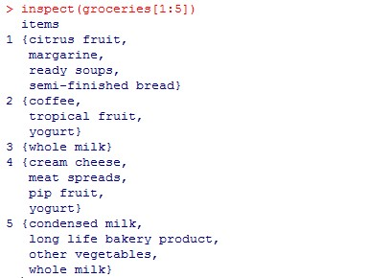

1. **itemFrequency(groceries(,1:3))**

itemFrequency is used for first three items (columns)

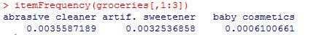

1. **itemFrequencyPlot(groceries, support = 0.1)**

It will Plot with min 10% frequency.

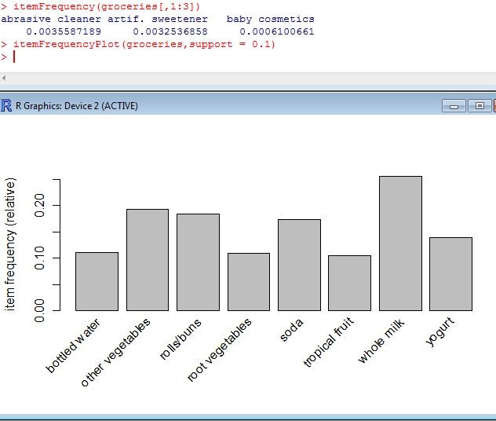

1. **image(groceries[1:5])** 
   * . Visualize entire matrix and all columns for first 5 transactions.

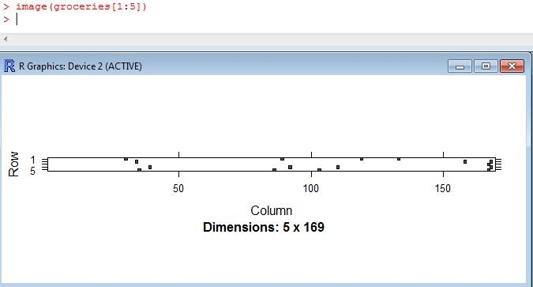

1. **image(sample(groceries, 100)) sample random 100 transactions in graph form.**

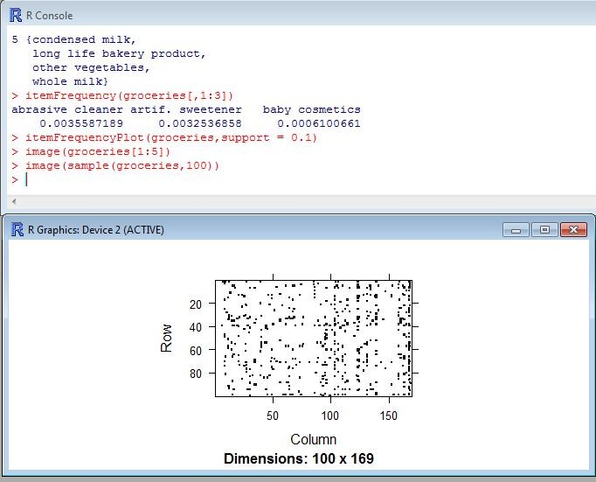

1. **apriori(groceries)**

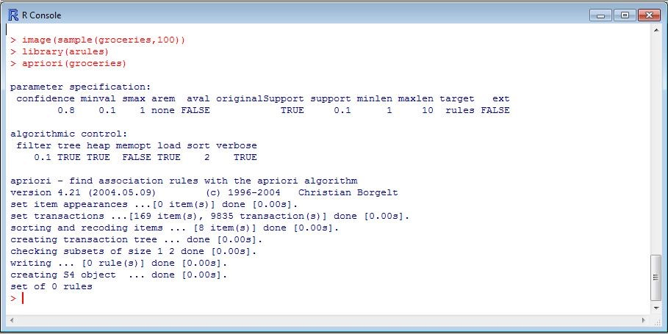

1. **groceryrules <- apriori(groceries, parameter = list(support = 0.006100661, confidence = 0.25,target=”rules”))** 
   * It will produces some set of rules.

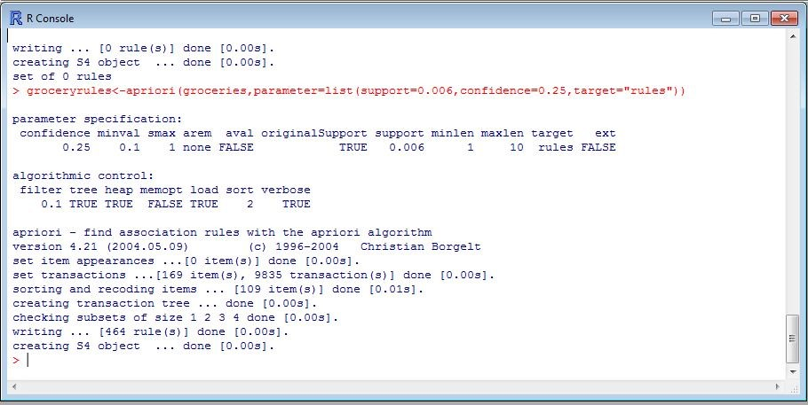

1. **After changing in confidence.**

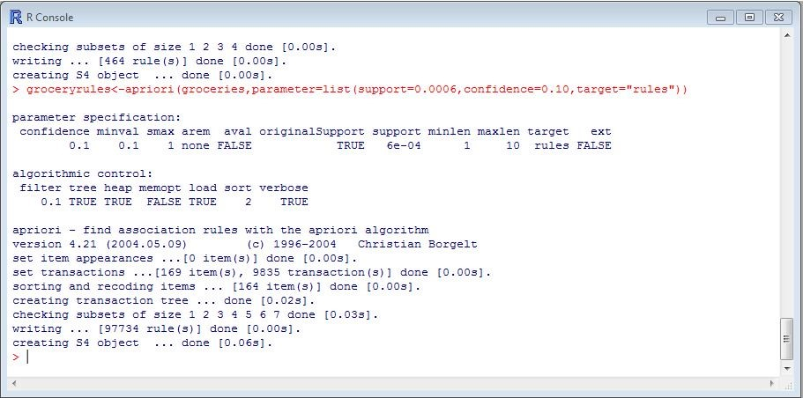

1. **Inspect (groceryrules)** 
   * It will display set of rules generated.

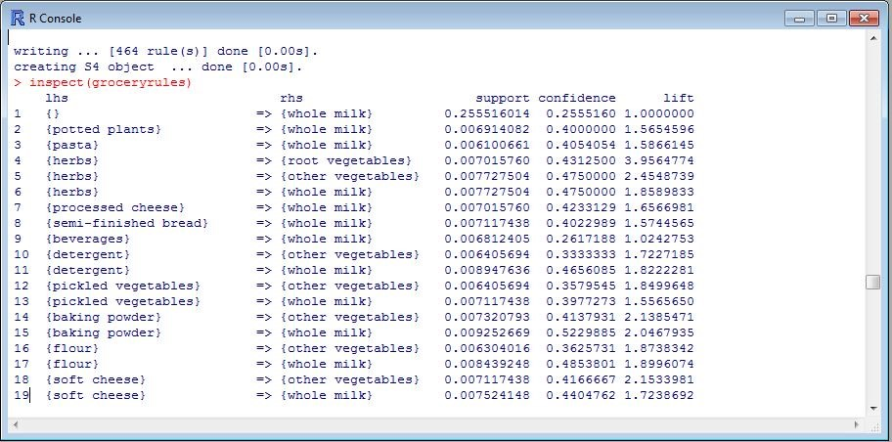

1. **Summary(groceryrules)** 
   * It will display the summary of groceryrules.

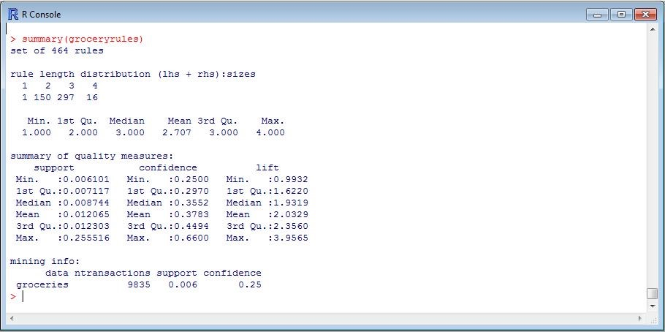

1. **Inspect(gloceryrules[1:3])**

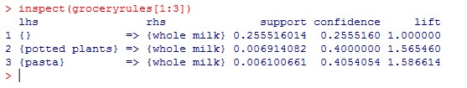

1. **inspect(sort(groceryrules, by = "lift")[1:5]) • Inspect rules with the highest lift.**

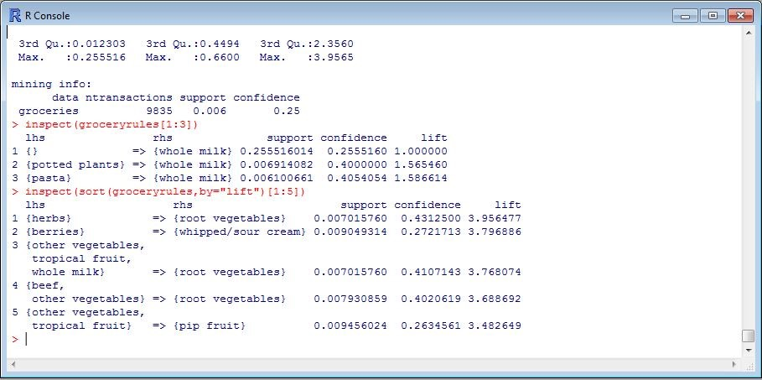

## Conclusion:

From this practical we learnt that how different types are charts are formed using the data and one gather the knowledge by analyzing this charts.

**Practical-5**

**Aim:** Perform Different Data Mining Activities using Weka Explorer Tool

(Open Source Data Mining Tool).& Experimental tool (Open source data mining)

**Software Required:** WEKA Explorer Tool

**Hardware Required:** Windows Platform with preinstalled Java SE

**Theory:**

Weka is a collection of machine learning algorithms for data mining tasks. The algorithms can either be applied directly to a dataset or called from your own Java code. Weka contains tools for data pre-processing, classification, regression, clustering, association rules, and visualization. It is also well-suited for developing new machine learning schemes.

Weka is open source software issued under the [**GNU General Public License**](http://www.gnu.org/licenses/gpl.html).

Step-1: Starting WEKA from the desktop



Step-2 : Preprocessing the data via WEKA explorer where different options gives us idea of performing data preprocessing tasks.

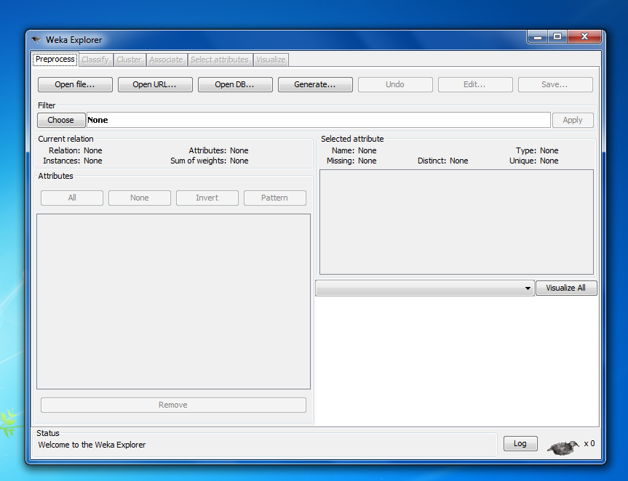

Step-3: Selecting a data set on which data analysis is to be performed

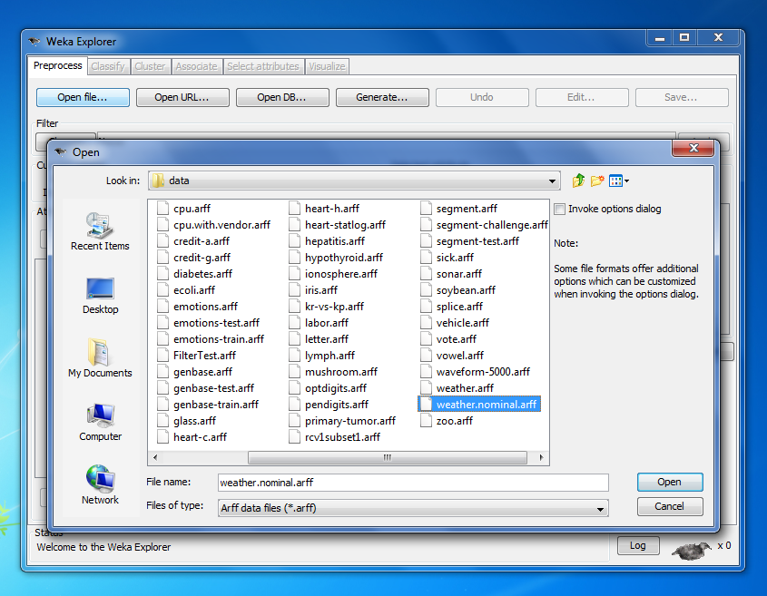

Step-4: Here the weather-nominal data set is selected on which various data analysis tasks are to be performed. In the dialog box it shows the plot of nominal-weather by default selection of attributed in the datasets.

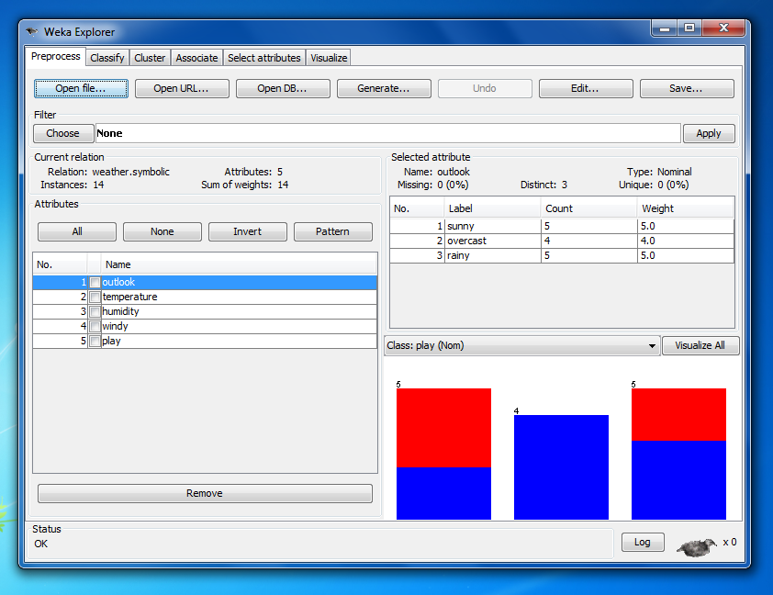

Step-5: The relation between different attributed of data sets can be mapped in this relation tool box where all the attributes are showed and their relation amongst themselves is to be found.

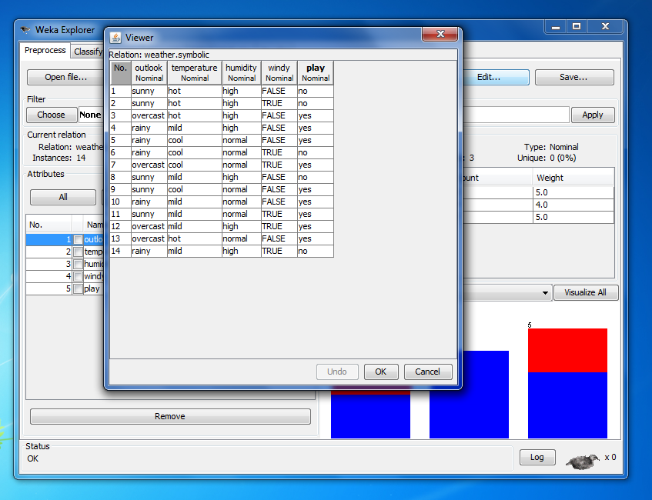

Step-6: Deciding a classifier is very important in WEKA explorer as it decides on which basis the data us to be analysed.

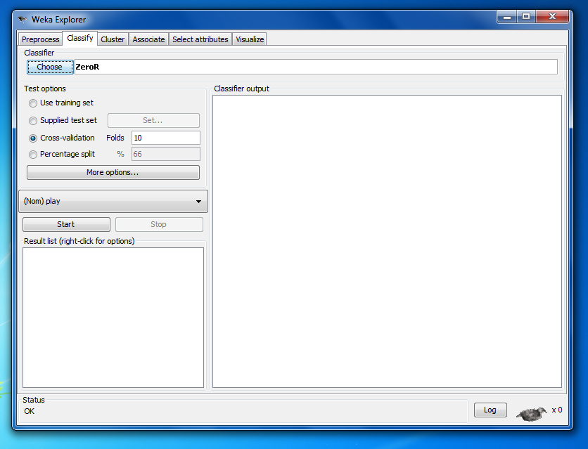

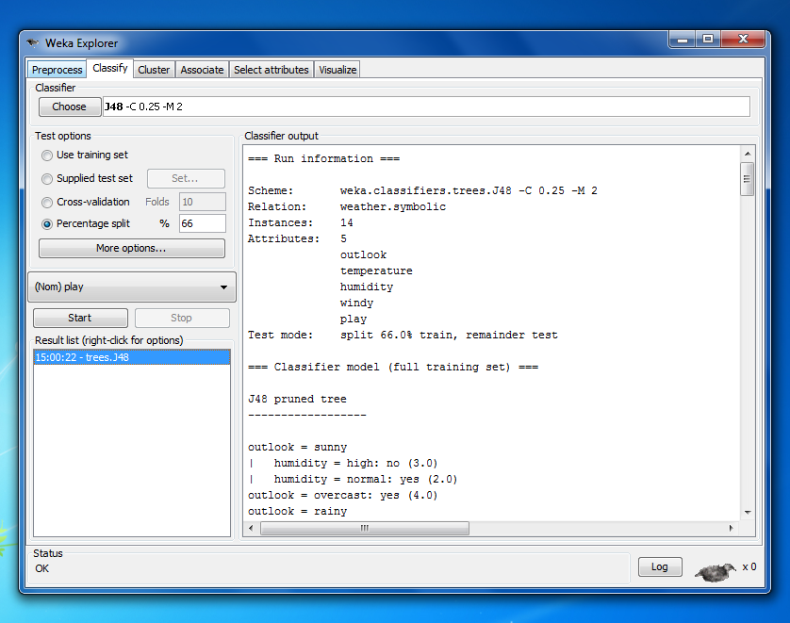

Step-7: Result in WEKA can be studied in different window based on the classifier chosen and it gives different type of plots according to the plots mentioned in various tree, barplots ,histogram etc.

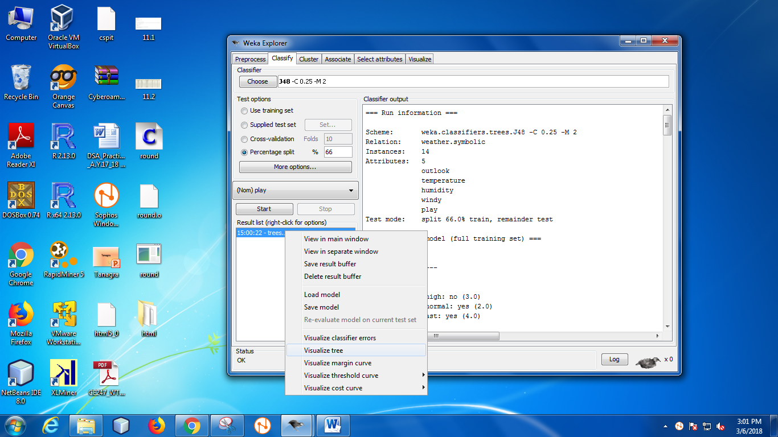

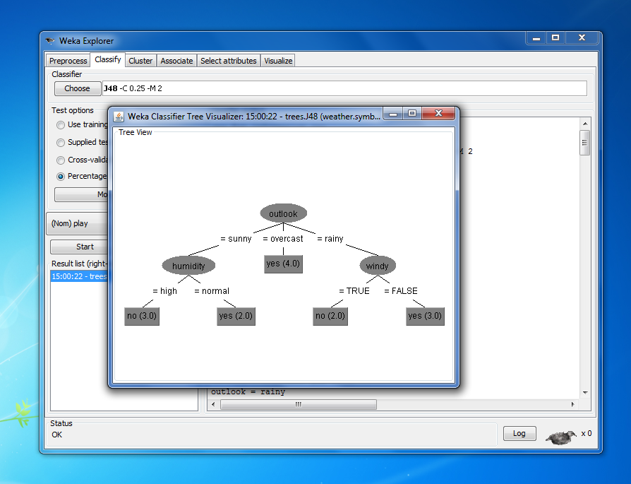

Step-8 : WEKA gives us the freedom of selecting the algorithm for association of data by default its Apriori Algorithm.

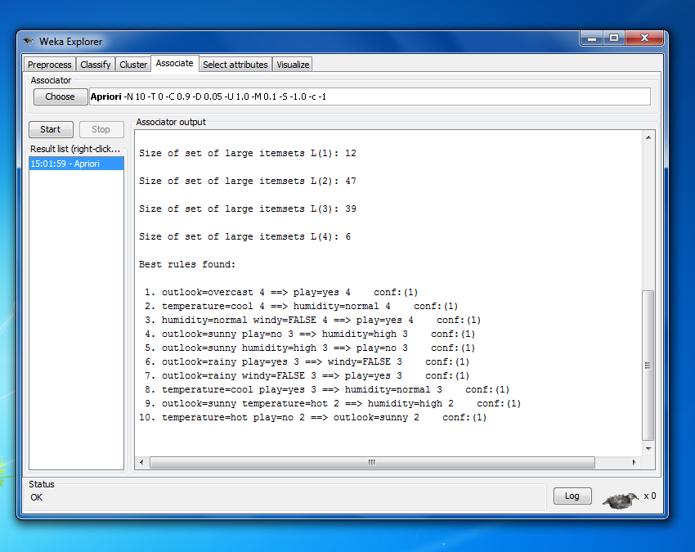

Step-9 : WEKA also allows us to specifically perform data visualization by taking certain attributes.

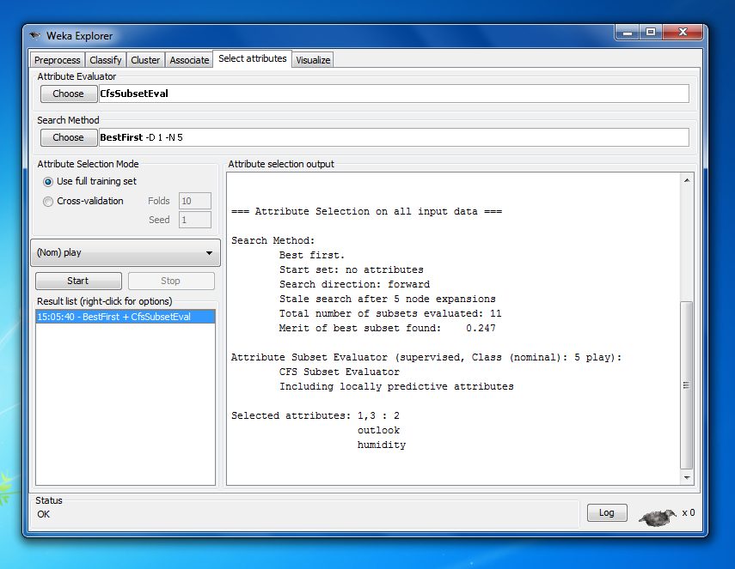

Step-10 : Here the figure shows the GNU plot matrix of selected attributes on which it produces certain different visualizations models.

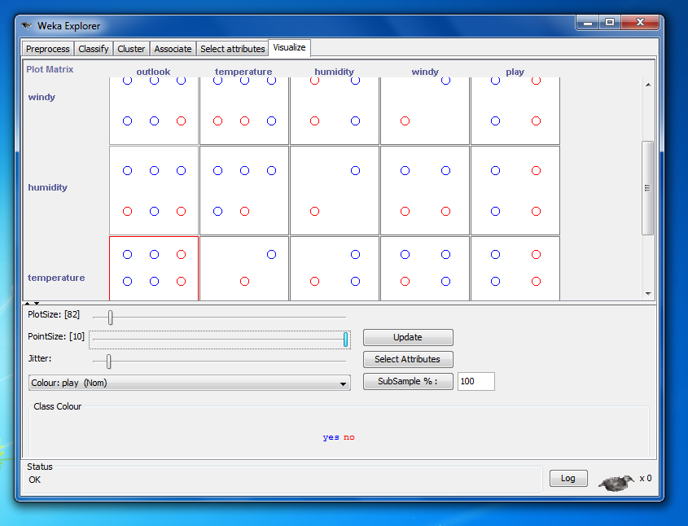

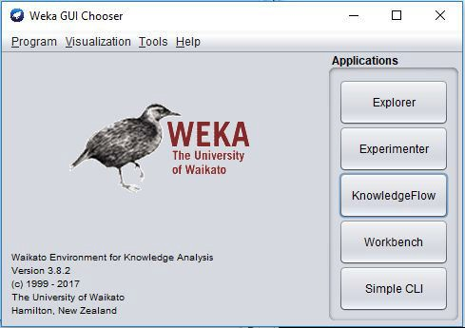

* WEKA is a state-of-the-art facility for developing machine learning (ML) techniques and their application to real-world data mining problems.
* It is a collection of machine learning algorithms for data mining tasks. The algorithms are applied directly to a dataset.
* WEKA implements algorithms for data preprocessing, classification, regression, clustering, association rules; it also includes a visualization tools.
* WEKA expects the data file to be in Attribute-Relation File Format (ARFF) file.

### Weka Options

1. **Weka Explorer:**Weka Explorer is an environment for exploring data.
2. **Experimenter**: Experimenter is an environment for performing experiments and conducting statistical tests between learning schemes.
3. **KnowledgeFlow**: Knowledge Flow is a Java-Beans-based interface for setting up and running machine learning experiments.

### WeatherNominal.arff

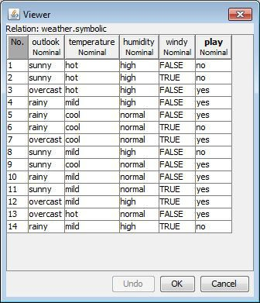

Weka Explorer preprocess:

* Once the data is loaded, WEKA recognizes attributes that are shown in the ‘Attribute’ window. Left panel of ‘Preprocess’ window shows the list of recognized attributes:

1. No. is a number that identifies the order of the attribute as they are in data file
2. Selection tick boxes allow you to select the attributes for working relation
3. Name is a name of an attribute as it was declared in the data file.

* The ‘Current relation’ box above ‘Attribute’ box displays

1. The base relation (table) name and the current working relation
2. The number of instances
3. The number of attributes

* During the scan of the data, WEKA computes some basic statistics on each attribute.
* The following statistics are shown in ‘Selected attribute’ box on the right panel of ‘Preprocess’ window:

1. Name is the name of an attribute
2. Type is most commonly Nominal or Numeric
3. Missing is the number (percentage) of instances in the data for which this attribute is unspecified
4. Distinct is the number of different values that the data contains for this attribute
5. Unique is the number (percentage) of instances in the data having a value for this attribute that no other instances have.

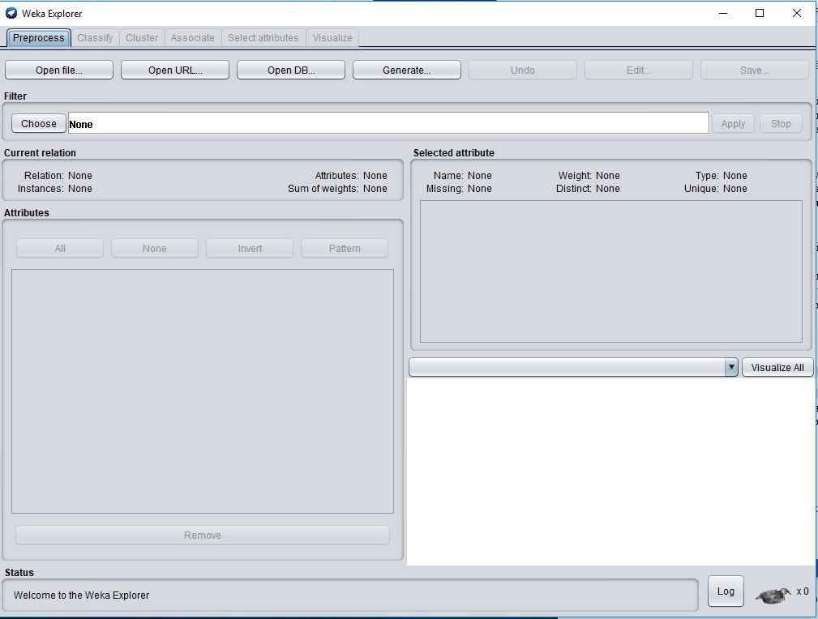

## Steps:

1. Click on preprocessing step. Open file .Open weathernominal.artf file

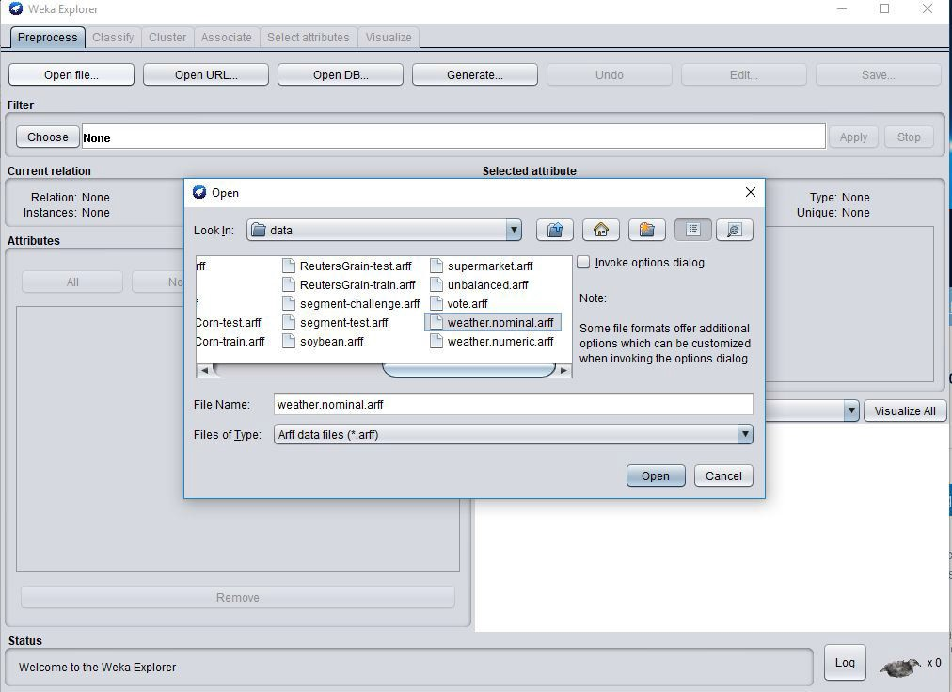  
2. Choose filter (supervised/unsupervised)

1. Choose tabe classify
2. Tree –decision tree (j48)
3. Use training set
4. Click on start

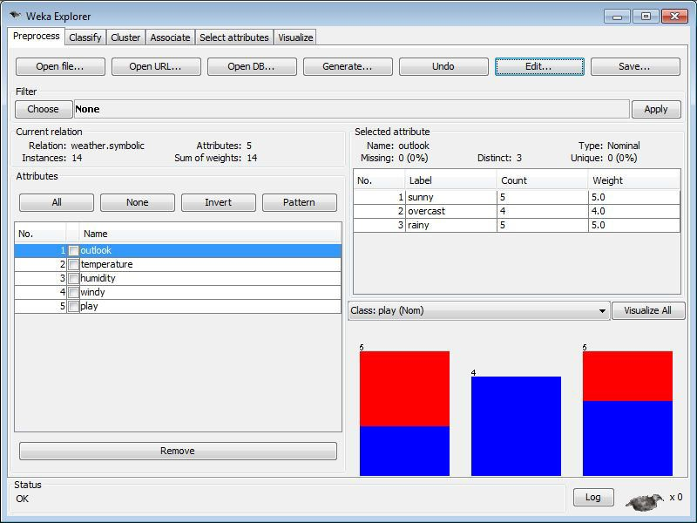

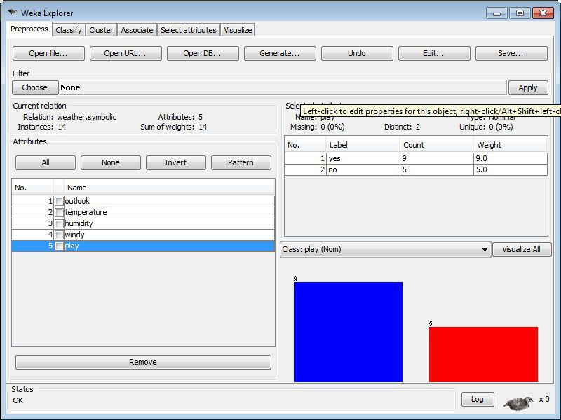

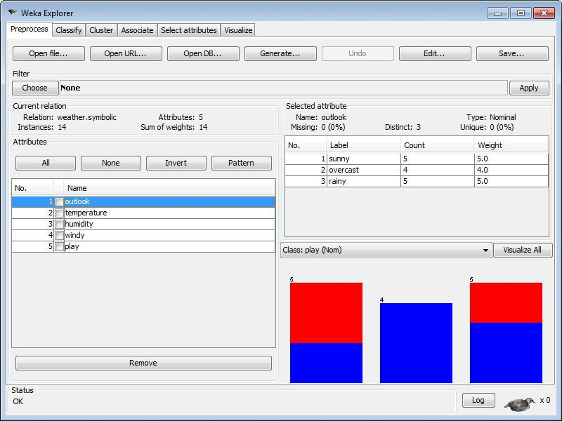

### Classify

* Classifiers in WEKA are the models for predicting nominal or numeric quantities.
* Click on ‘Choose’ button in the ‘Classifier’ box just below the tabs and select C4.5 classifier WEKA → Classifiers →Trees -> J48
* Setting Test Options
  1. Use training set: Evaluates the classifier on haw well it predicts the class of the instances it was trained on.
  2. Supplied test set: Evaluates the classifier on how well it predicts the class of a set of instances loaded from a file. Clicking on the ‘Set…’ button brings up a dialog allowing you to choose the file to test on.
  3. Cross-validation: Evaluates the classifier by cross-validation, using the number of folds that are entered in the ‘Folds’ text field.
  4. Percentage split: Evaluates the classifier on how well it predicts a certain percentage of the data, which is held out for testing. The amount of data held out depends on the value entered in the ‘%’ field.

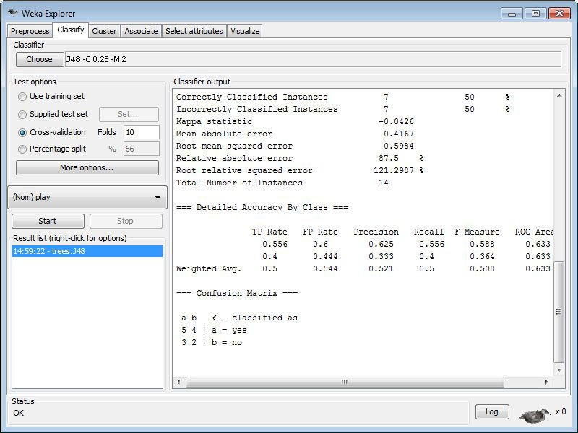

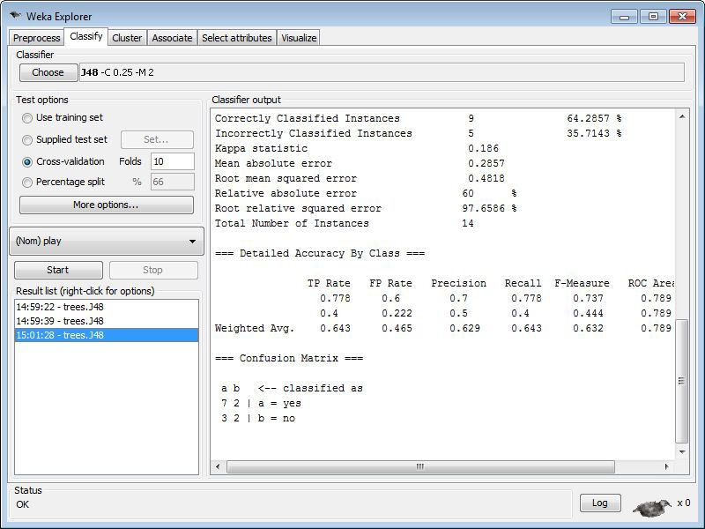

### Associate

* WEKA contains an implementation of the Apriori algorithm for learning association rules.
* It works only with discrete data and will identify statistical dependencies between groups of attributes
* Apriori can compute all rules that have a given minimum support and exceed a given confidence.
* The association rule scheme cannot handle numeric values;

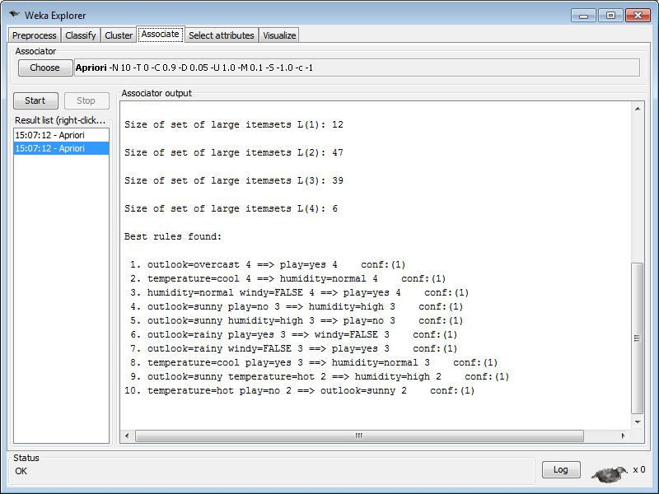

WEKA EXPERIMENTAL

Weka is a collection of machine learning algorithms for data mining tasks. The algorithms can either be applied directly to a dataset or called from your own Java code. Weka contains tools for data pre-processing, classification, regression, clustering, association rules, and visualization.

**Step-1**: Starting WEKA from the desktop



**Step-2 :** After clicking New default parameters for an Experiment are defined.

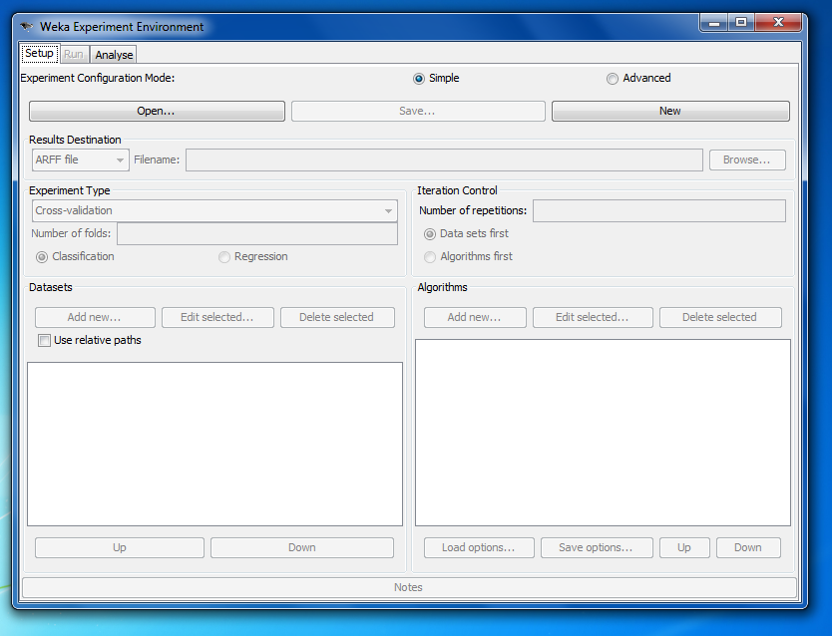

**Step-3:** One can add dataset files either with an absolute path or with a relative one. The latter makes it often easier to run experiments on different machines, hence one should check Use relative paths, before clicking on Add new.... In this example, open the data directory and choose the weather.arff dataset

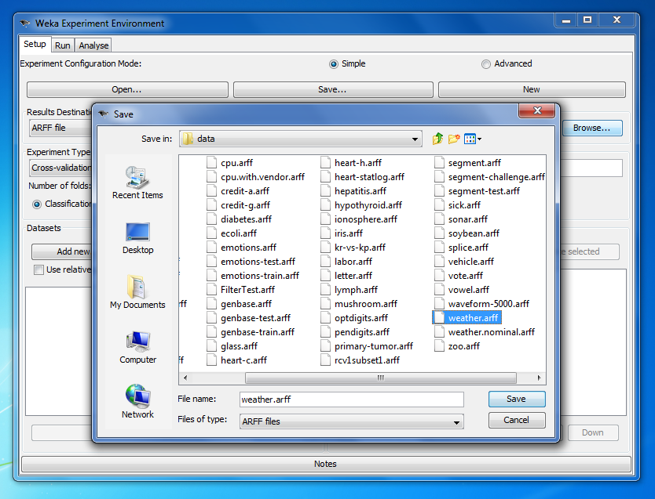

**Step-4:** With the Choose button one can open the GenericObjectEditor and choose another classifier. Additional algorithms can be added again with the Add new... button, e.g., the J48 decision tree.

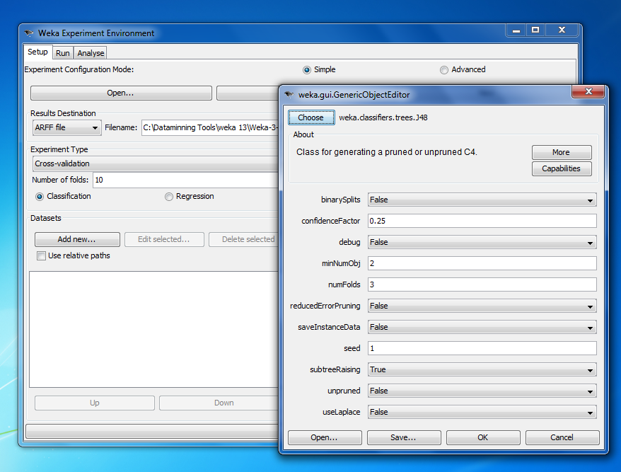

**Step-5**: To run the current experiment, click the Run tab at the top of the Experiment Environment window. Click Start to run the experiment. If the experiment was defined correctly, the 3 messages shown above will be displayed in the Log panel.

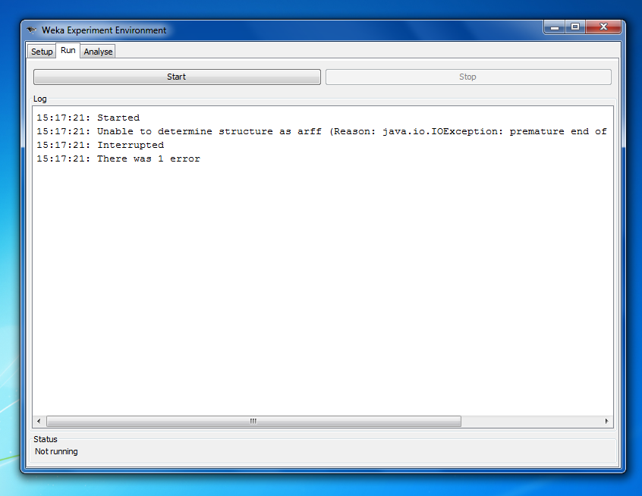

**Step-6**: For Analyzing the current experiment, click on the Analyse tab on the Environment window.

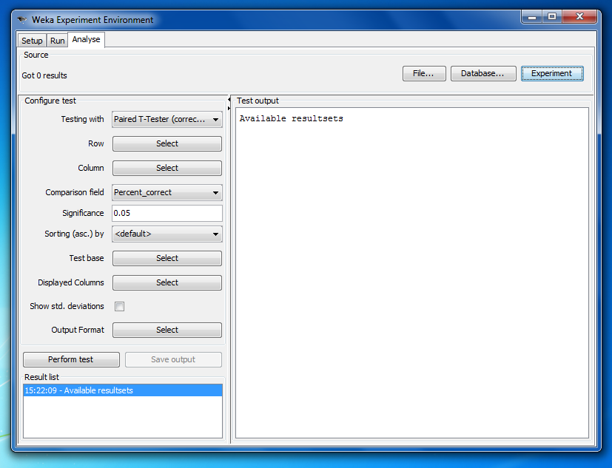

**Step-7**: In the Analyse tab, click on the perform test button and it will analyse the current dataset and will generate the confusion matrix.

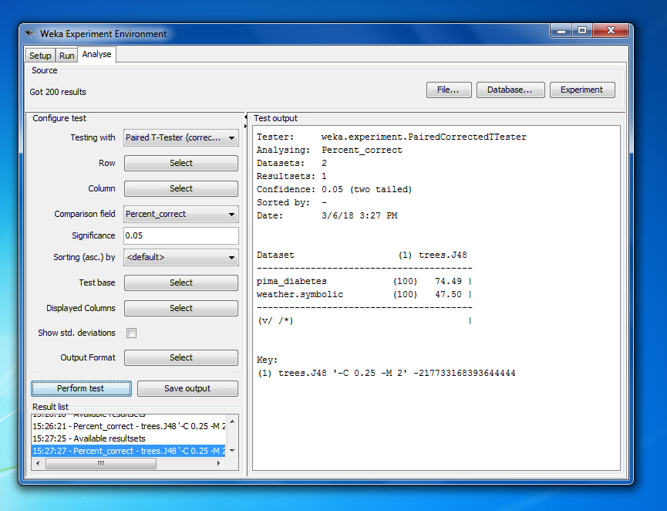

**Conclusion:**

Thus, above we have studied the explorer window to weka tool. And we have studied weka experimental.

**Practical 6**

**AIM:** Performing Linear Regression Analysis using RProgramming.

**SOFTWARE REQUIRED: RStudio**

**HARDWARE REQUIRED:** --

**THEORY:**

Regression analysis is a very widely used statistical tool to establish a relationship model between two variables. One of these variable is called predictor variable whose value is gathered through experiments. The other variable is called response variable whose value is derived from the predictor variable.

In Linear Regression these two variables are related through an equation, where exponent (power) of both these variables is 1. Mathematically a linear relationship represents a straight line when plotted as a graph. A non-linear relationship where the exponent of any variable is not equal to 1 creates a curve.

The general mathematical equation for a linear regression is −

**y = ax + b**

Following is the description of the parameters used −

* y is the response variable.
* x is the predictor variable.
* a and b are constants which are called the coefficients.

**lm() Function:**

This function creates the relationship model between the predictor and the response variable.

Syntax: The basic syntax for lm() function in linear regression is −

**lm(formula, data)**

Following is the description of the parameters used −

* formula is a symbol presenting the relation between x and y.
* data is the vector on which the formula will be applied.

**predict() Function:**

Syntax: The basic syntax for predict() in linear regression is −

**predict(object, newdata)**

Following is the description of the parameters used −

* object is the formula which is already created using the lm() function.
* newdata is the vector containing the new value for predictor variable.

**PROGRAM:** Establishing simple regression.

**CODE:**

s1 <- c(6.42,7.05,6.68,8.42,8.41,9.05,9.00,9.10)

s2 <- c(7.4,8.05,7.78,8.0,8.96,9.0,9.0,9.0)

relation <- lm(s2~s1)

print(relation)

print(summary(relation))

**OUTPUT:**

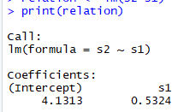

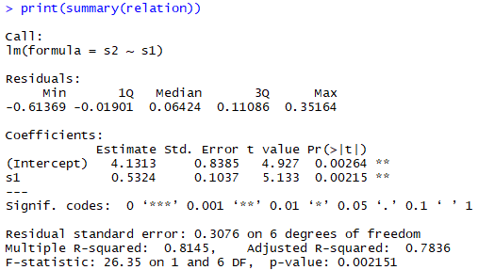

**PROGRAM:** Visualizing Regression Graphically.

**CODE:**

s1 <- c(6.42,7.05,6.68,8.42,8.41,9.05,9.00,9.10)

s2 <- c(7.4,8.05,7.78,8.0,8.96,9.0,9.0,9.0)

relation <- lm(s2~s1)

plot(s2,s1,main = "Grades of two students", abline(lm(s1~s2)))

**OUTPUT:**

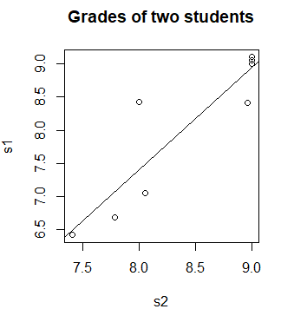

**CONCLUSION:**

By this practical, we have learnt regression between the data and also to generate scatter plot on the data.

**Practical 7**

**AIM:** Perform Different Data Mining Activities using Weka Knowledge

Flow Tool (Open Source Data Mining Tool).

**S/W:** Weka Tool

**H/W: --** Computer

**Theory:**

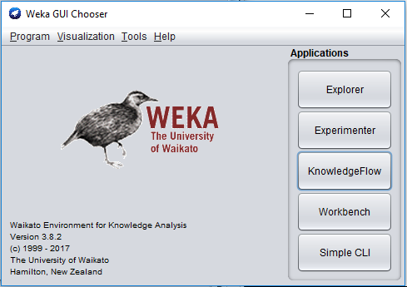

**Weka Knowledge Flow**

* Java-Beans-based interface for setting up and running machine learning experiments
* Data sources, classifiers, etc. are beans and can be connected graphically
* Data “flows” through components

e.g.  data source → filter → classifier → evaluator

* Layouts can be saved and loaded again later
* Features:
* view models produced by classifiers for each fold in a cross validation
* intuitive data flow style layout
* process data in batches or incrementally
* process multiple batches or streams in parallel (each separate flow executes in its own thread)
* chain filters together
* visualize performance of incremental classifiers during processing (scrolling plots of classification accuracy, RMS error, predictions etc.)
* plugin facility for allowing easy addition of new components to the Knowledge Flow

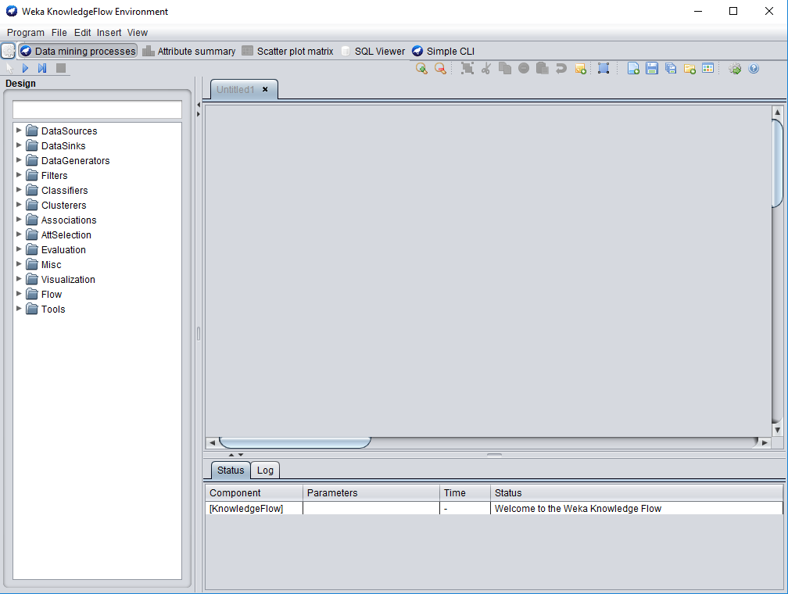

**Steps:**

1. Select arff loader

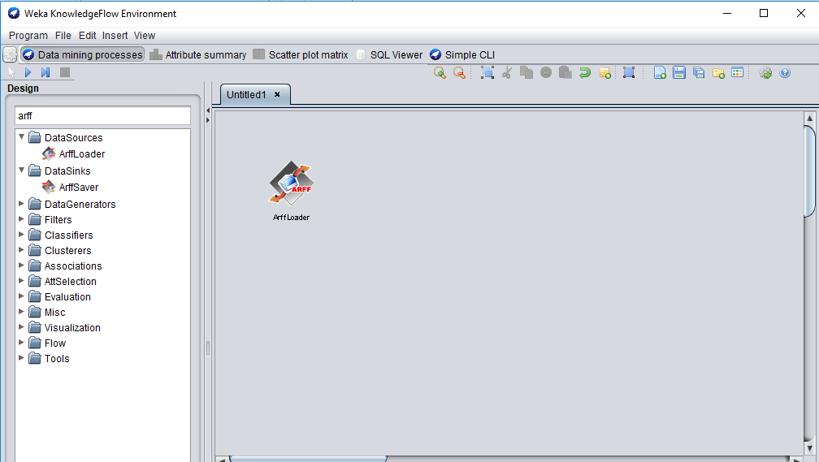

Right click -> configure and brows iris data

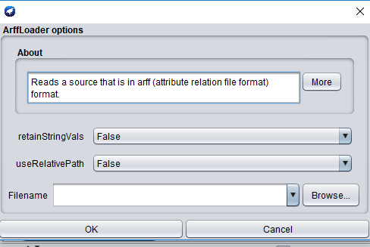

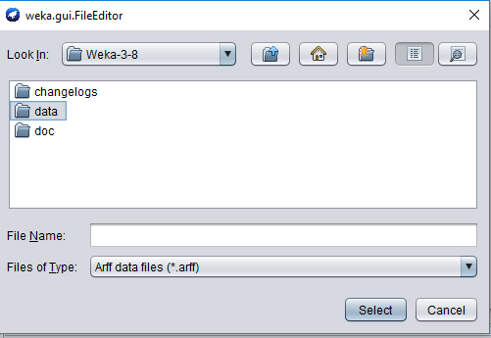

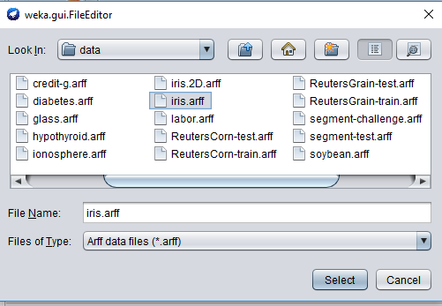

1. Go to filter -> attribute selection double click on it

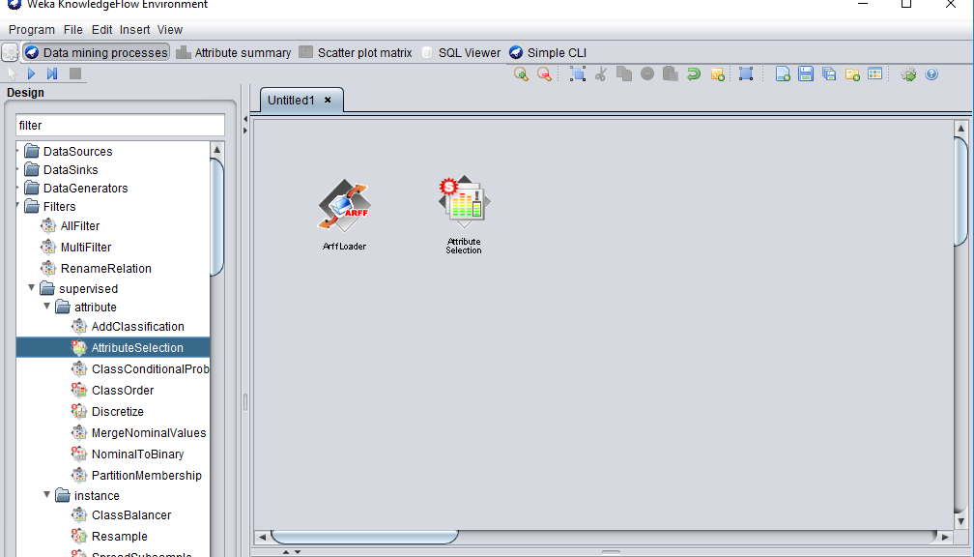

1. Again go to attribute right click dataset (stretch)

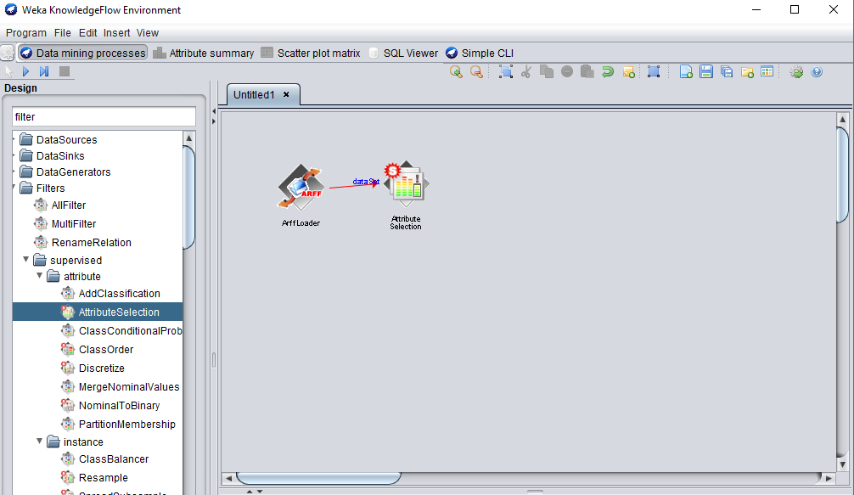

1. Evolution : choose train test maker

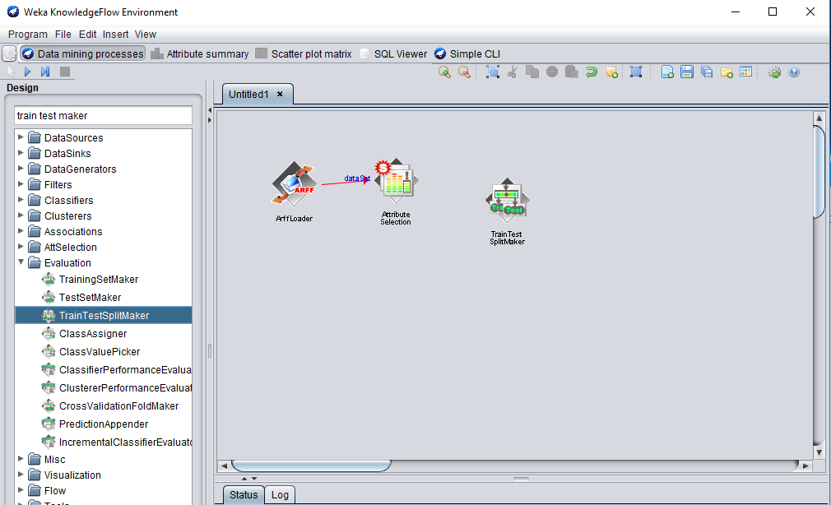

1. Goto classifier: trees and j48 (to evalution by right click and choose batch classifier)

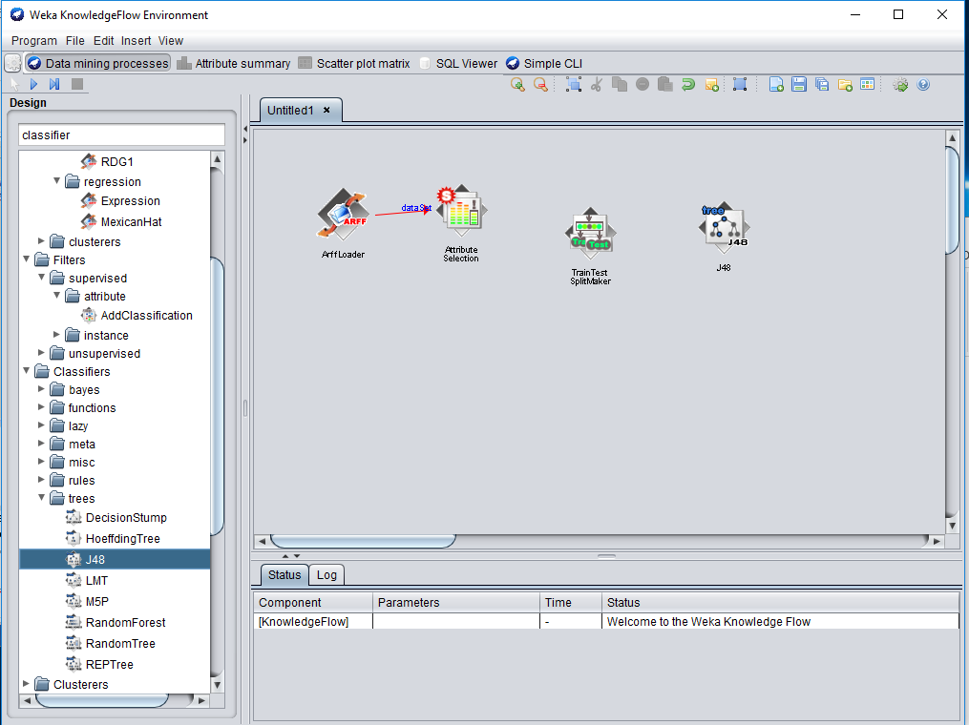

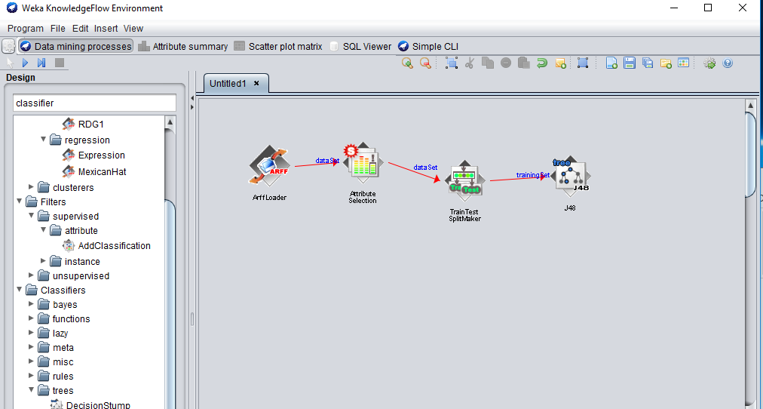

1. Net evaluation classifier performance evaluation (to visualization test)

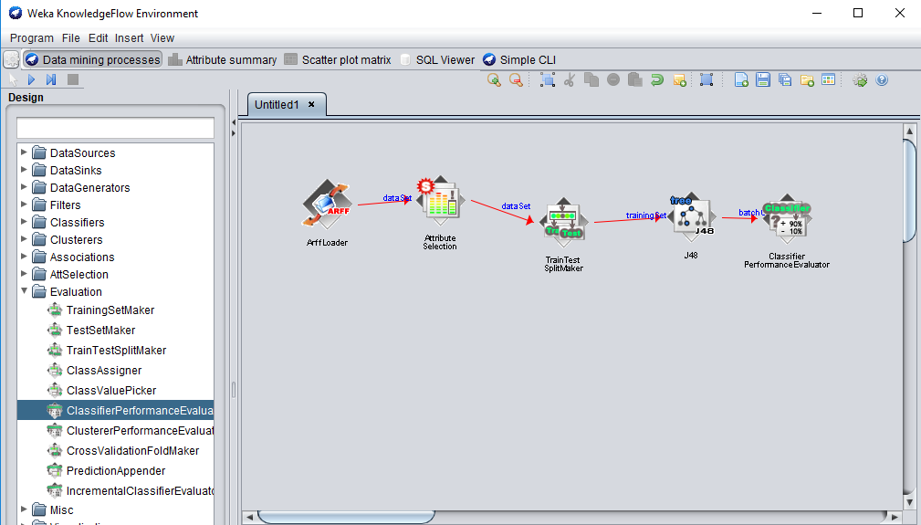

1. Visualization (text view)

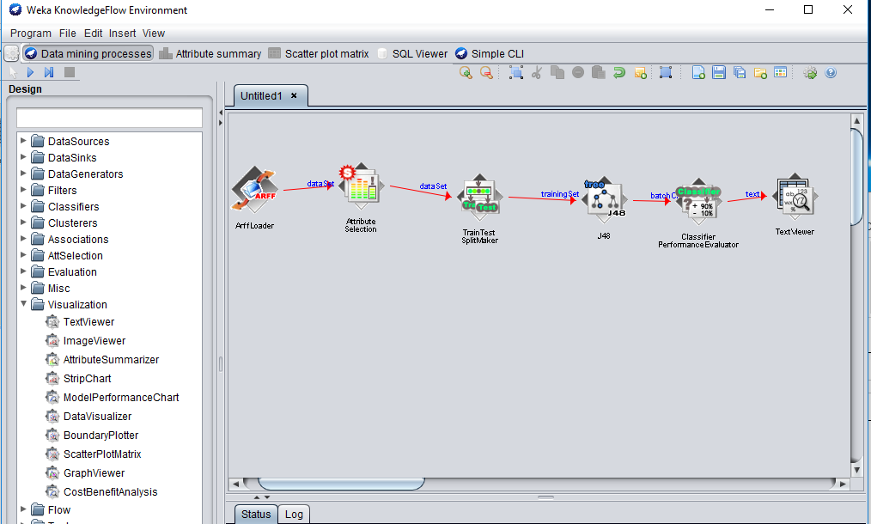

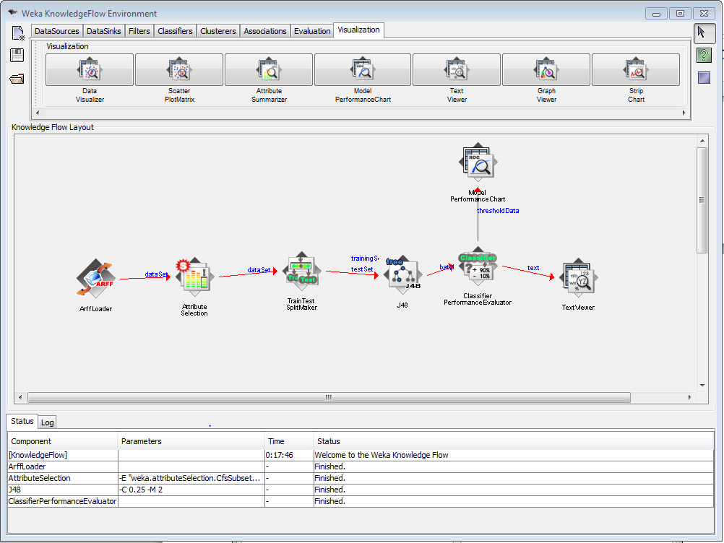

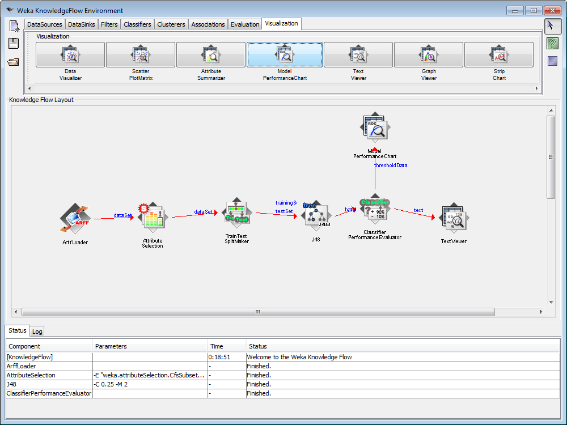

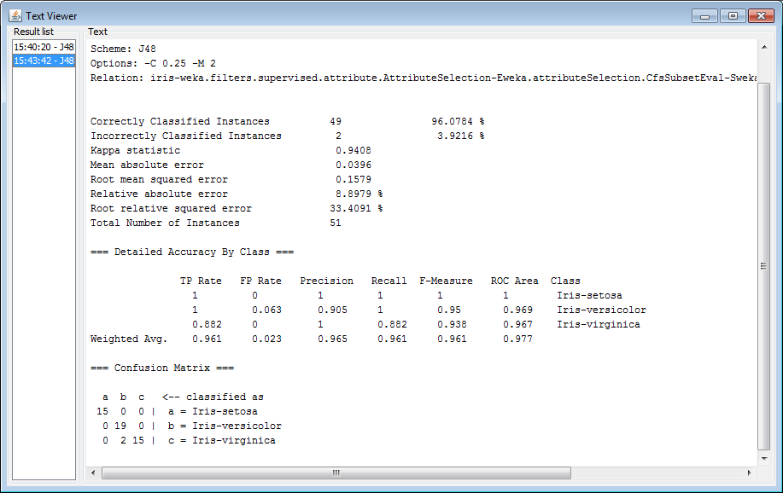

**Conclusion:**

From this practical we learnt about Different Data Mining Activities using Weka Knowledge Flow Tool.

**Practical 8**

**AIM:** Performing Time Series Analysis using RStudio.

**SOFTWARE REQUIRED:** RStudio

**HARDWARE REQUIRED: --**

**THEORY:**

Time series is a series of data points in which each data point is associated with a timestamp. A simple example is the price of a stock in the stock market at different points of time on a given day. Another example is the amount of rainfall in a region at different months of the year. R language uses many functions to create, manipulate and plot the time series data. The data for the time series is stored in an R object called time-series object. It is also a R data object like a vector or data frame.

The time series object is created by using the **ts()** function.

Syntax: The basic syntax for ts() function in time series analysis is −

[timeseries.object.name](http://timeseries.object.name/) **<- ts (data, start, end, frequency)**

Following is the description of the parameters used −

* data is a vector or matrix containing the values used in the time series.
* start specifies the start time for the first observation in time series.
* end specifies the end time for the last observation in time series.
* frequency specifies the number of observations per unit time.

**PROGRAM: Plot a simple time series.**

**CODE:**

library(xlsx)

grade<-c(6.42,7.05,6.68,8.42,8.41,9.0,8.52,8.44)

grade.timeseries<-ts(grade,start = 1,frequency = 1)

print(grade.timeseries)

plot(grade.timeseries)

**OUTPUT:**

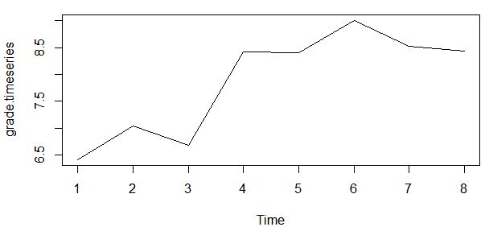

**PROGRAM: Plot multiple time series.**

**CODE:**

gradeA <- c(6.42,7.05,6.68,8.42,8.41,9.0,8.52,8.44)

gradeB <- c(7.4,8.05,7.7,8.0,8.96,9.0,9.0,9.0)

grade.timeseries <- ts(gradeA,start= 1 ,frequency = 1 )

combined.grade <- matrix(c(gradeA,gradeB),nrow = 8)

grade.timeseries <- ts(combined.grade,start = 1,frequency = 1)

print(grade.timeseries)

plot(grade.timeseries)

summary(grade)

**OUTPUT:**

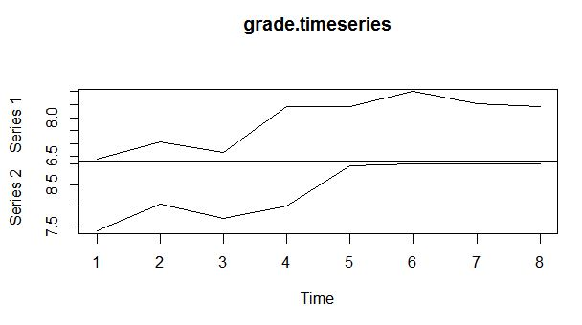

**CONCLUSION:**

By this practical, we have learnt creating different time series using R Programming.

**PRACTICAL-9**

**AIM:** Perform Different Data Mining Activities using XL Miner Tool./ Tanagra/ Sipina/Rapid Miner/Orange/Knime/Cluto3

**SOFTWARE REQUIREMENT:** OrangeTool

**HARDWARE REQUIREMENT**: N/A

**Snapshots:**

**Step 1:** Choose “Orange” from Programs. The first interface that appears looks like the one given below.



**Step 2**: Select the file from the data and place it on the layout. Similarly drag and drop all Components. Now Connect the File to the data table it will connect two Components.

Similarly do this for all components.

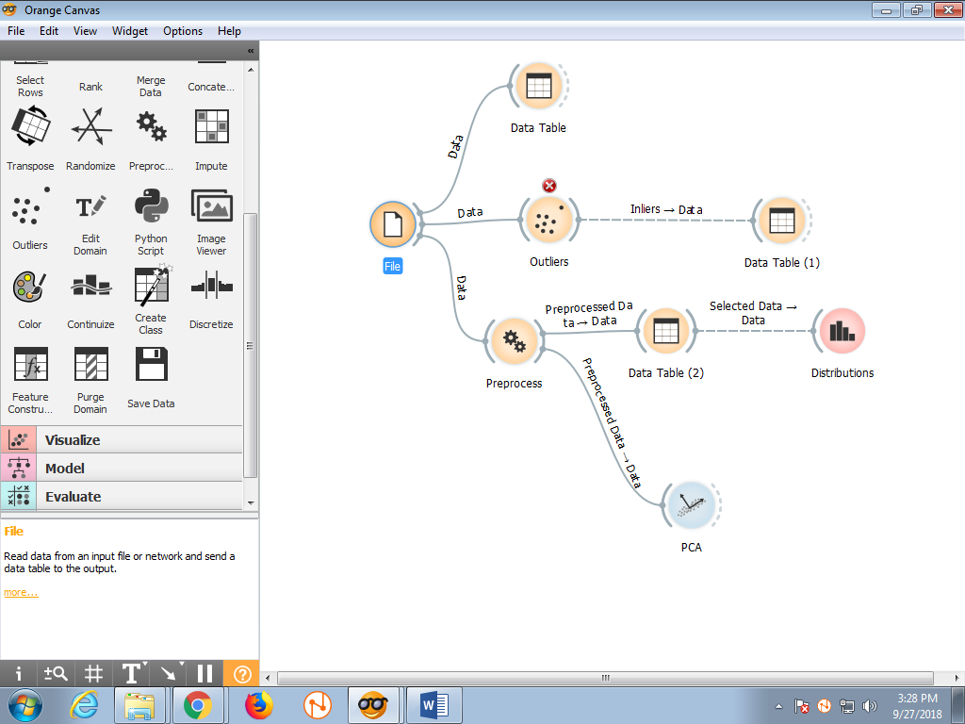

**Step 3:** Now, click on the file to load a dataset. We will select the adult sample dataset. Basically it is both Categorical and numerical data.

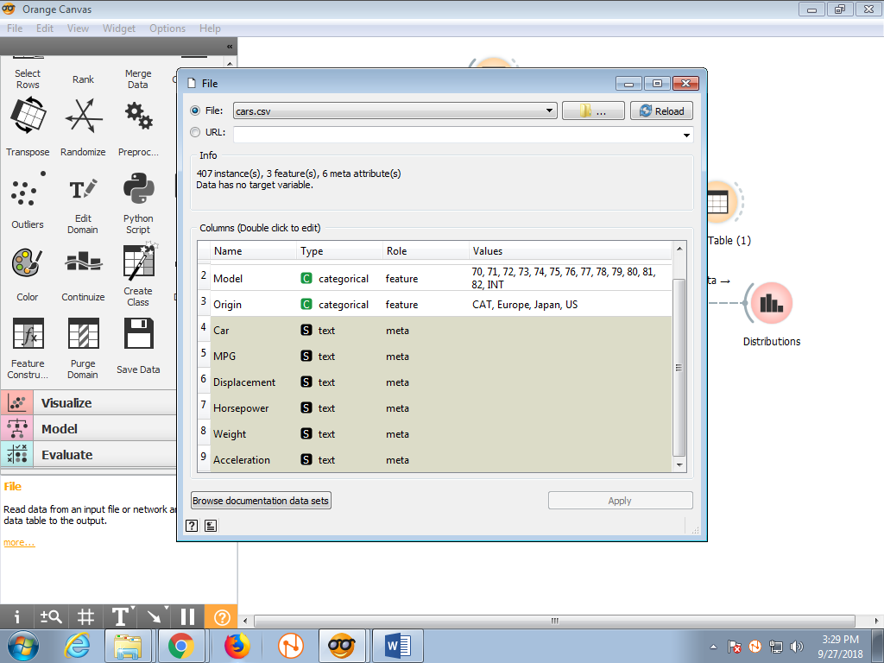

**Step 4:** Now, click on the data table to visualize the data. It will show 977 Instance with 14 features and Discrete Class with 2 values. We will also see the numeric value by clicking on the visualize numeric values. Here We perform Data Cleaning and Handling missing values. We get (1.0%missing values) at the right side of the table. From the table we can see there are some values which are not filled so we have to filled it. We have to reduce the missing values to zero.

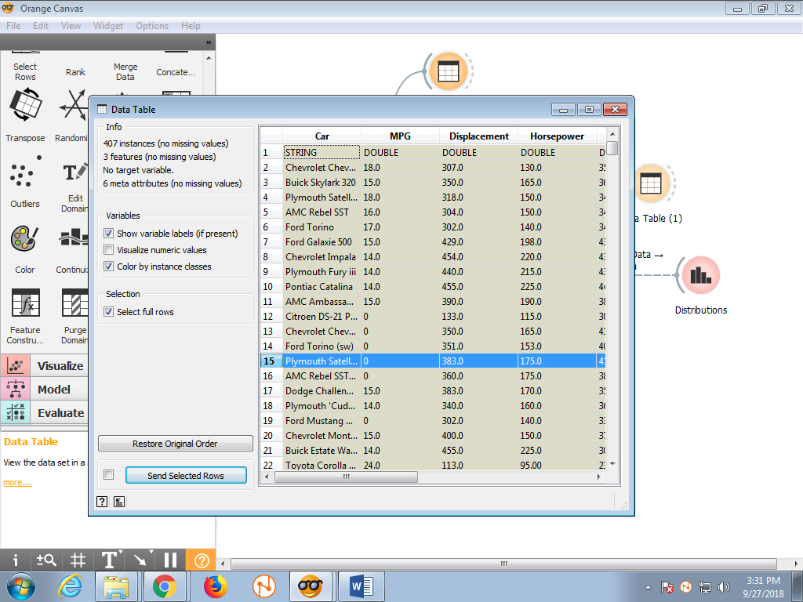

**Step 5:** Next Click on the Outliers. We have Outliers to detect number of instances. It shows the 380 inliers and 597 outliers.

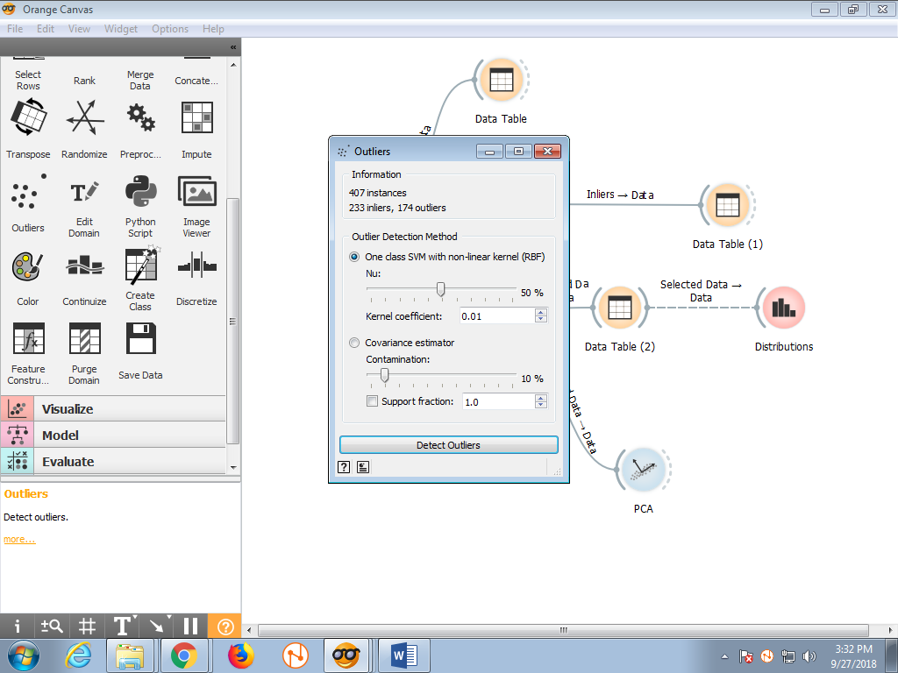

**Step 6:** By detecting the outlier next click on the data table it only shows the outlier instance only.

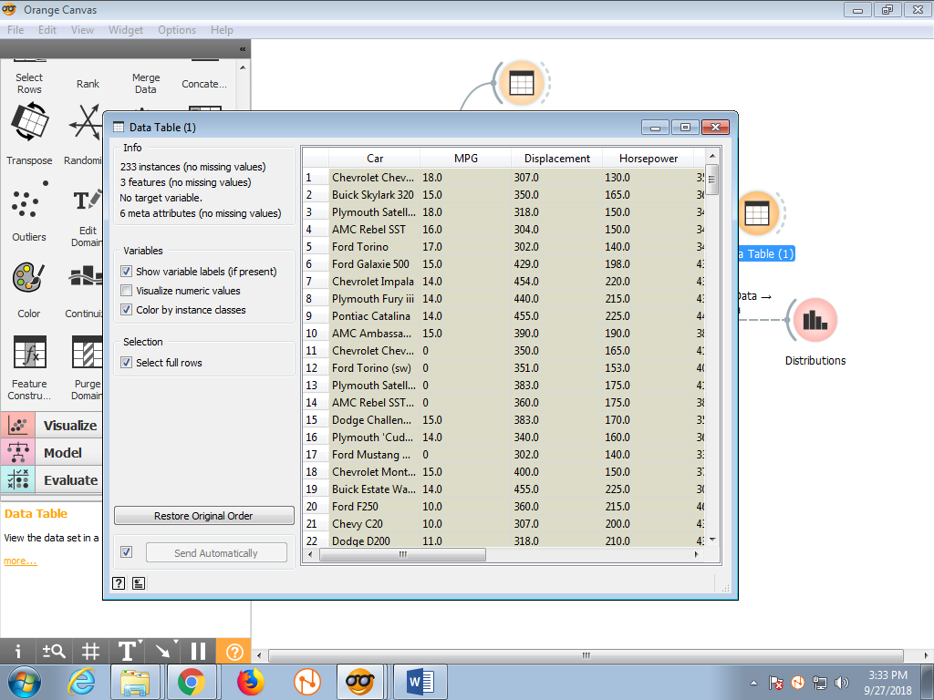

**Step 7:** Now we perform the preprocessing tasks of data to handle the missing values. So Drag and drop the tasks and place on the right side of the screen. We take impute missing values.

**Step 8:** So, Here we finally get the no missing value and all the missing data will be filled. We also replace random value also by clicking on the second button. It will place any value for their given selected attribute only. We also remove the missing value if we remove then we have less number of instances.

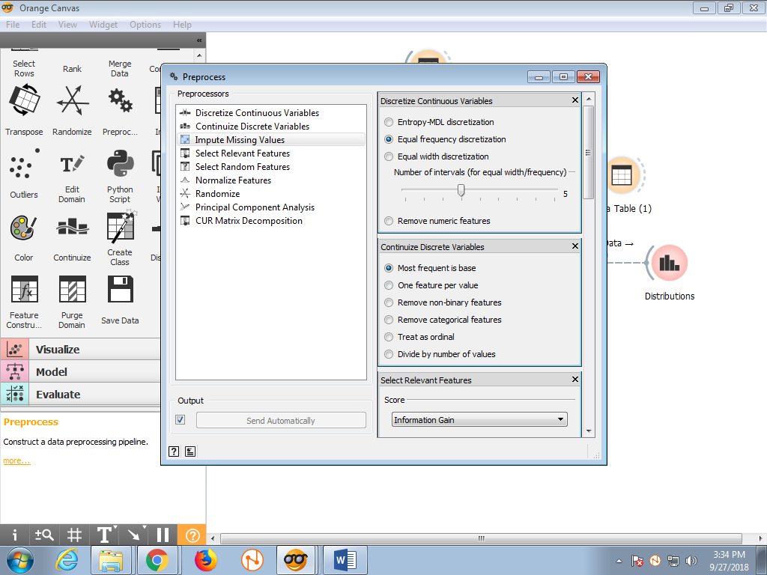

**Step 9:** So, Here we finally get the no missing value and all the missing data will be filled. We also replace random value also by clicking on the second button. It will place any value for their given selected attribute only. We also remove the missing value if we remove then we have less number of instances.

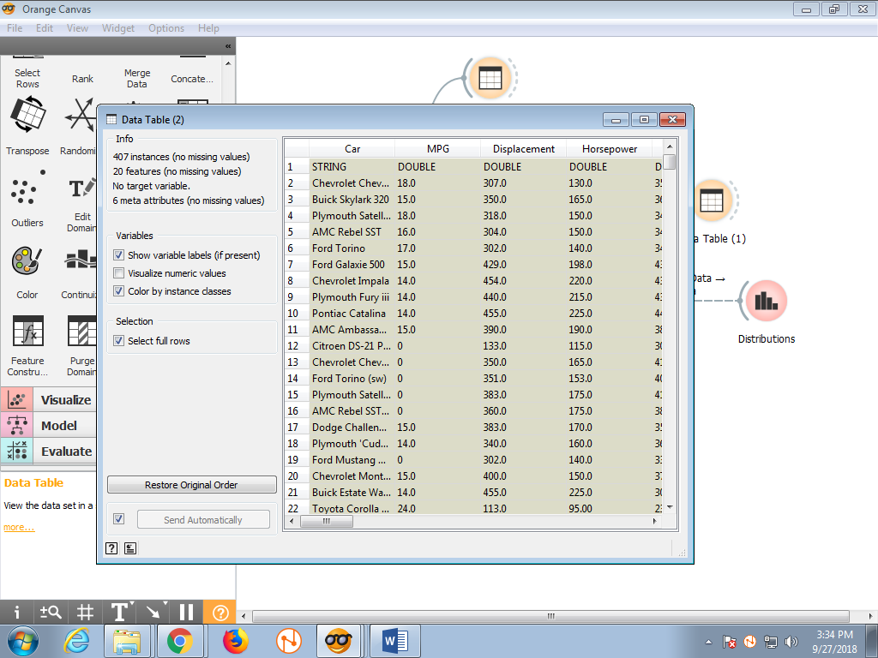

**Step 10:** Let us take another preprocess tasks. We have Discretize Continuous Variables for binning methods. Now select Equal Width Discretization with Interval of Five.

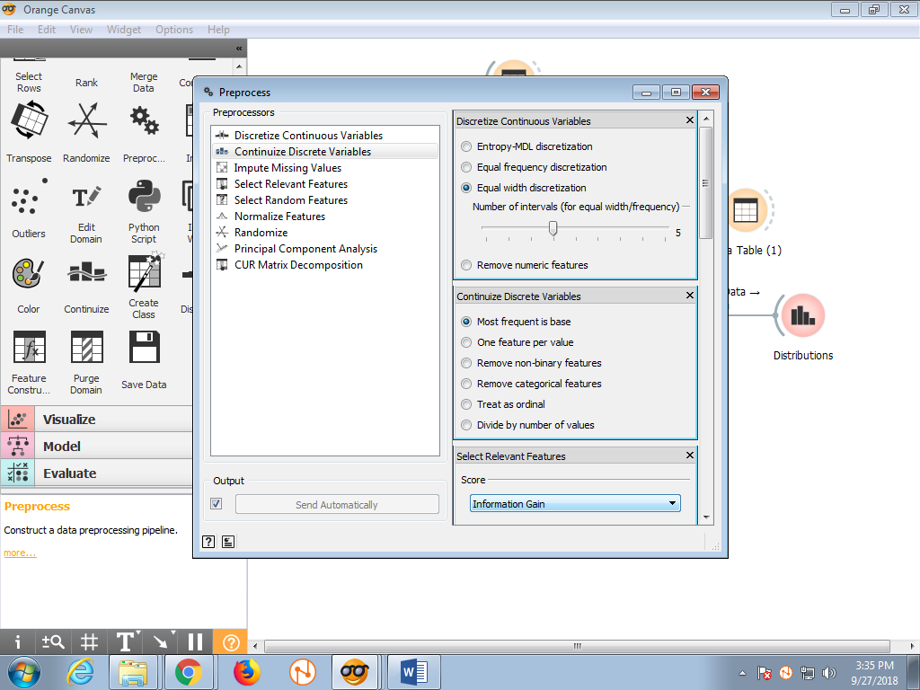

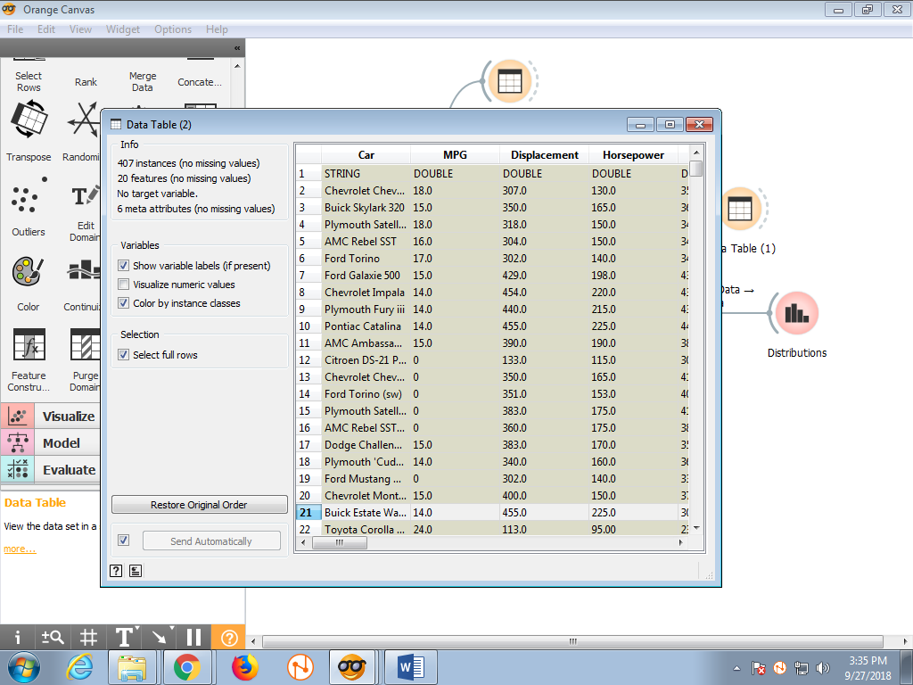

**Step 11:** Next we have Principal Component Analysis. We take 10 Components.

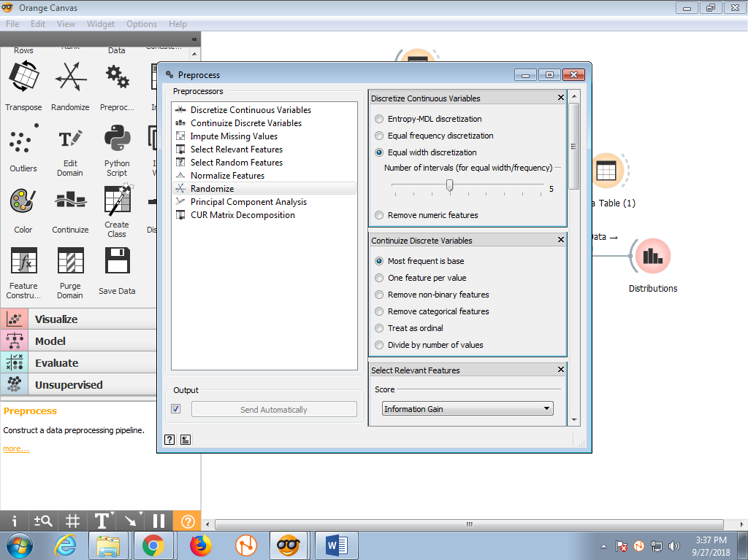

**Step 12:** So, Here we get the 10 Principle Component for the Given Y Attributes. Based on the data table. Next Click on the Distributions It shows the Graph of Density vs PC1 for Given Y.

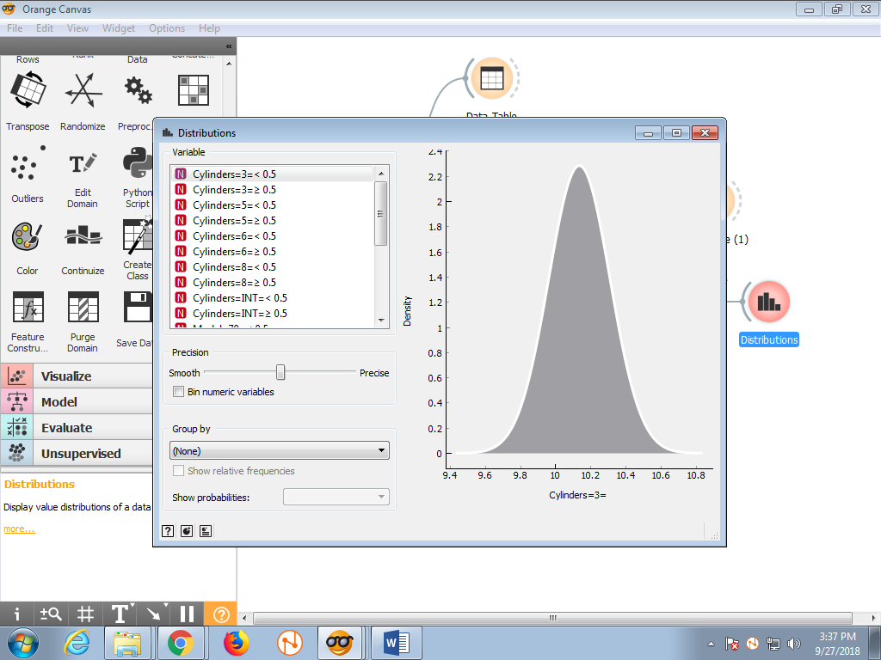

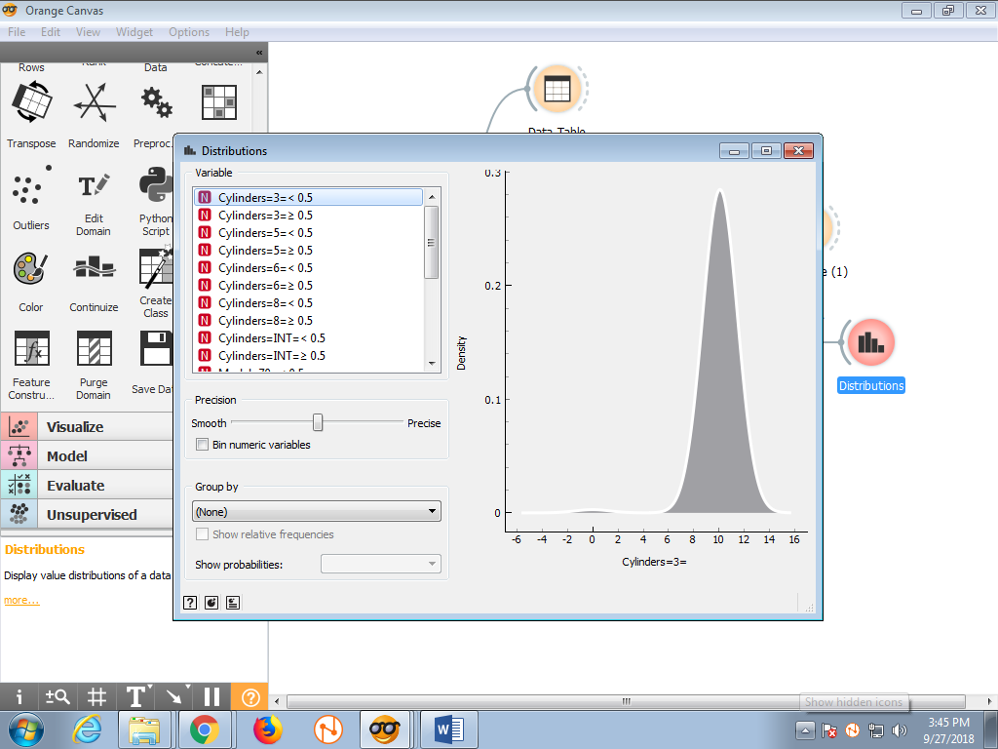

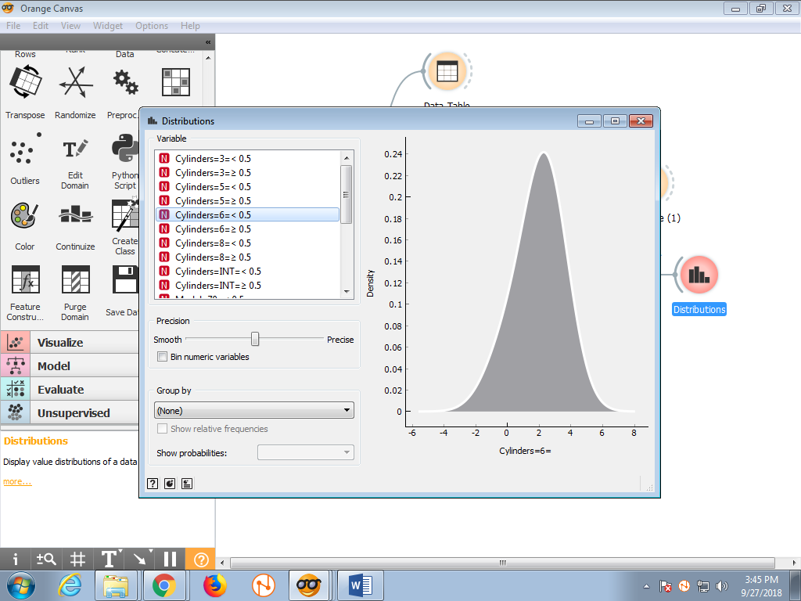

**Step 13:** Now Click on the PCA component.

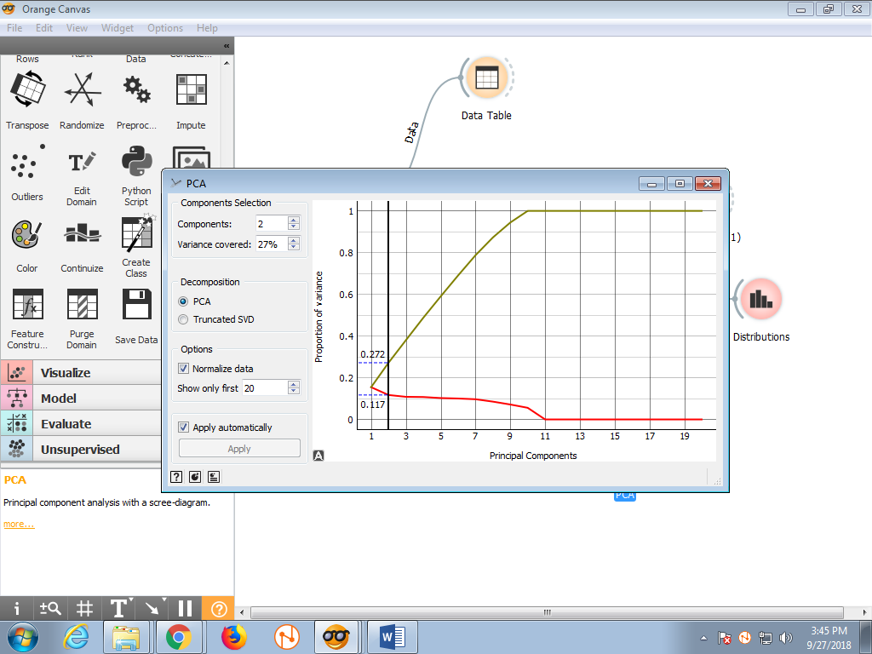

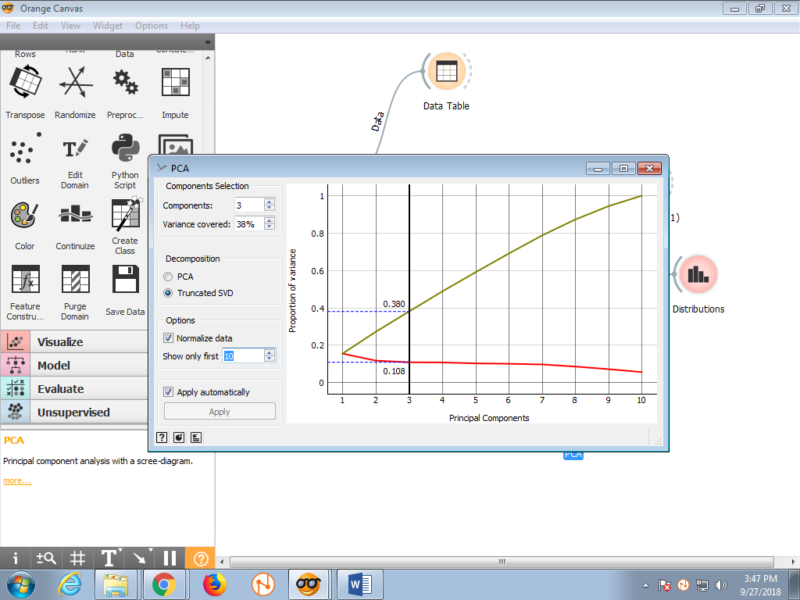

**Step 14:** ROC analysis.



**CONCLUSION:**

Hence. From this practical we learnt Open Source Data Mining Tool. Perform different Data Pre-processing techniques like cleaning, handling missing values using Orange Tool.